CO4 – AT1 - Article Review- Low
Hemavathi. M
192512222
COURSE NAME: Advance Wireless Communication Systems /
5G / 6G Communication Systems
COURSE CODE: ECA5609

Title: Edge Computing over Satellite Networks for Future Wireless Systems
Abstract
Edge computing over satellite networks combines satellite communication with edge computing to provide fast and reliable wireless services. Data is processed closer to the user instead of sending everything to a distant cloud. This reduces latency, bandwidth usage, and network congestion. It is useful for 5G/6G, IoT, disaster management, autonomous vehicles, and remote-area communication.
Technical Implementation
- LEO satellites provide low-latency communication.
- Edge servers are placed at satellites or ground stations.
- IoT and mobile devices send data to the nearest satellite.
- Edge nodes process important data locally.
- AI-based task offloading decides whether data is processed at the device, edge, or cloud.
- Basic architecture:
User → LEO Satellite → Edge Node → Cloud
- This improves latency, bandwidth efficiency, scalability, and QoS.
Conclusion
Edge computing with satellite networks is a promising technology for future 5G/6G systems. It provides low latency, efficient data processing, reliable connectivity, and better resource utilization, especially in remote areas.

Delay Efficient FA-Assisted Satellite Communication Network With Mobile Edge Computing
Jingwen Zhao, Graduate Student Member, IEEE, Ming Chen, Zhaohui Yang, Member, IEEE, Hao Xu, Senior Member, IEEE, Cunhua Pan, Senior Member, IEEE, Tony Q. S. Quek, Fellow, IEEE,
and Kai-Kit Wong, Fellow, IEEE

Abstract—Mobile edge computing-space–air–ground inte-grated network (MEC-SAGIN) is emerging as a crucial component of future wireless systems. Despite its potential, addressing network fluctuations while ensuring continuous low-latency computing services in highly dynamic environments remains a significant challenge. To address this issue, this article proposes a fluid antenna (FA)-assisted MEC-SAGIN system, which enhances channel transmission conditions and reduces uplink task offloading latency by flexibly adjusting the antenna ports of edge computing users equipped with FAs. Specifically, we aim to minimize the maximum total computational delay (TCD) of edge computing tasks for ground users (GUs) and the satellite user (SU) by jointly optimizing the task offloading strategies, computational resource allocation, FA port positions, uncrewed aerial vehicle (UAV) location, and the receive beam-

Received 28 March 2025; revised 2 October 2025, 3 November 2025,
and 24 November 2025; accepted 12 December 2025. Date of publication
16 December 2025; date of current version 23 February 2026. This work was supported in part by the Key Project of Basic Research of Jiangsu Province under Grant BK20253014; in part by the Key Research and Development Plan Projects of Jiangsu Province under Grant BE2022316; in part by the National Key Research and Development Program of the Ministry of Science and Technology of China under Grant 2023YFB2905603; in part by Zhejiang Key Research and Development Program under Grant 2023C01021; in part by the Young Elite Scientists Sponsorship Program by China Association for Science and Technology (CAST) under Grant 2023QNRC001; in part by the Fundamental Research Funds for the Central Universities under Grant K2023QA0AL02; in part by the National Natural Science Foundation of China under Grant 62501152 and Grant U25A20398; in part by the Fundamental Research Funds for the Central Universities under Grant 2242025R10001; in part by the Engineering and Physical Sciences Research Council (EPSRC) under Grant EP/W026813/1; in part by the National Research Founda-tion, Singapore and the Infocomm Media Development Authority under its Communications and Connectivity Bridging Funding Initiative; and in part by Zhejiang Key Laboratory of Multimodal Communication Networks and Intelligent Information Processing. (Corresponding authors: Ming Chen; Tony Q. S. Quek.)
Jingwen Zhao, Ming Chen, Hao Xu, and Cunhua Pan are with the National Mobile Communications Research Laboratory, Southeast University, Nan-jing 210096, China (e-mail: zhaojingwen@seu.edu.cn; chenming@seu.edu.cn; hao.xu@seu.edu.cn; cpan@seu.edu.cn).
Zhaohui Yang is with the College of Information Science and Elec-tronic Engineering, Zhejiang University, Hangzhou 310027, China (e-mail: yang zhaohui@zju.edu.cn).

Tony Q. S. Quek is with Singapore University of Technology and Design, Singapore 487372, and also with the Department of Electronic Engineering, Kyung Hee University, Yongin 17104, South Korea (e-mail: tonyquek@sutd.edu.sg).
Kai-Kit Wong is with the Department of Electronic and Electrical Engi-neering, University College London, WC1E 7JE London, U.K., and also with the Department of Electronic Engineering, Kyung Hee University, Yongin-si, Gyeonggi-do 17104, South Korea (e-mail: kai-kit.wong@ucl.ac.uk.).
Digital Object Identifier 10.1109/JIOT.2025.3645072
forming matrix. To solve this nonconvex problem, we employ the block coordinate descent (BCD) technique to decompose the original problem into four subproblems. The subproblems are optimized using a combination of low-complexity iterative algorithms and the projected gradient descent (PGD) method to refine communication and computation configurations as well as FA port selection. Simulation results demonstrate that the FA-assisted scheme significantly improves the TCD performance of the MEC-SAGIN system. It maintains transmission stability and reliability in dynamic environments while outperforming conventional fixed-position antennas (FPAs) and random-port antenna schemes.
Index Terms—Fluid antenna (FA), mobile edge computing (MEC), resource allocation, satellite communication, uncrewed aerial vehicle (UAV).
- Introduction
- Motivation and Scope
W
ITH the rapid development of the sixth-generation (6G) mobile communication systems, the number of wireless devices worldwide is growing exponentially [1], [2]. However, the connection of large-scale wireless devices to a network results in the demand for services that require high bandwidth and computational resources [3], [4]. Mobile edge computing (MEC), as one of the emerging technologies in 5G, effectively reduces communication latency by migrating computational resources from centralized data centers to the edge of the network, thereby providing powerful support for latency-sensitive applications [5], [6], [7], [8]. Nevertheless, there are still many challenges that MEC should address in practical applications, including the complexity of resource allocation, the quality-of-service (QoS) assurance, and the coordination of multiaccess technologies [9], [10]. These chal-lenges constrain the scalable deployment of MEC, particularly in highly dynamic environments and large-scale user access
scenarios.
In this context, the space–air–ground integrated network (SAGIN), as a promising architecture, has attracted signifi-cant attention from both academia and industry [11], [12]. By integrating satellites, uncrewed aerial vehicles (UAVs), and ground networks, SAGIN realizes seamless communica-tion between air, space, and ground, demonstrating immense potential in application scenarios such as remote areas, postdisaster recovery, and wide-area coverage [13]. The

2327-4662 © 2025 IEEE. All rights reserved, including rights for text and data mining, and training of artificial intelligence and similar technologies. Personal use is permitted, but republication/redistribution requires IEEE permission.
See https://www.ieee.org/publications/rights/index.html for more information.

deployment of SAGIN not only extends the coverage of communication networks through the coordinated schedul-ing and management of cross-domain resources but also enhances robustness and flexibility [14]. This facilitates new opportunities for the further advancement of MEC, establish-ing SAGIN as an effective solution to address challenges such as insufficient network coverage and communication latency.
Existing efforts have been made to achieve efficient commu-nication and computation offloading in MEC-enabled SAGIN systems [15], [16], [17]. The existing literature primarily focuses on how to utilize the multilayered network structure of SAGIN to enhance the computational and communication capabilities of MEC, such as by extending the coverage of edge computing through satellite networks or dynami-cally deploying computational resources via UAVs [18], [19]. Specifically, the works in [18], [20], and [21] have explored various designs for uplink communication and computation offloading in SAGIN. Considering the services of MEC in the SAGIN system, ground users (GUs) can typically offload their computational tasks to edge servers on UAVs or satel-lites, thereby conserving energy and/or reducing computation latency for GUs [22], [23], [24]. Nonetheless, while existing studies have primarily concentrated on the distinct advantages of MEC and SAGIN networks, there remains a lack of in-depth research on the challenges arising from the integration of these two technologies in novel network architectures. These challenges include increased network complexity and the optimization of resources in dynamic environments. In particular, the communication among satellites, UAVs, and GUs within SAGIN is susceptible to multipath fading and link instability in highly dynamic environments, which imposes significant challenges on the offloading of computational tasks and resource allocation in MEC.
To address these challenges, the integration of fluid antenna (FA) technology has gradually emerged as a prominent solu-tion [25], [26], [27], [28]. By dynamically adjusting the antenna position within a constrained spatial domain, FAs can better exploit spatial diversity, thereby mitigating the impact of multipath fading on signal transmission [29], [30], [31]. Specifically, FA technology enables the adjustment of the antenna position vector (APV) and antenna weight vector (AWV) to achieve full array gain in the desired direction and interference nulling in multiple undesired direc-tions [32], [33]. Compared to conventional fixed-position antennas (FPAs), FAs exhibit superior efficiency and adapt-ability, thus further improving the reliability and stability of the communication network [34], [35]. Recent studies have explored FAs in MEC and in SAGIN as two largely separate threads. Specifically, in MEC networks, the reconfigurabil-ity of FAs enables opportunistic port selection and position adaptation, which improves the uplink signal-to-interference-plus-noise ratio (SINR), reduces the transmit power required for reliable offloading, and consequently shortens end-to-end latency [36], [37]. In SAGIN networks, FAs pro-vide interference containment and adaptive beam footprints, while port diversity suppresses interbeam leakage, which enhances link reliability under rapid geometric variation and
Doppler effects, and therefore improves spectral reuse com-pared with fixed-pattern arrays [38]. However, these studies analyze the benefits of FAs within isolated MEC or SAGIN settings.
With FA technology already demonstrating its effectiveness in both MEC and SAGIN systems, as well as its adaptability to complex and dynamic environments, this technology serves as an effective solution for providing flexible adjustment capabilities to alleviate edge computing network congestion in high-speed SAGIN environments. Therefore, we propose to utilize FAs in the integrated MEC-SAGIN hybrid network to address the limitations of the existing network architectures. To the best of our knowledge, there is currently no research on the application of FA technology for enabling edge computing within SAGIN networks. To fill this research gap, we propose a novel SAGIN architecture that integrates satellite, UAV, GUs, and FA technology to enhance the stability and reliability of MEC transmission links in highly dynamic environments. This architecture facilitates the coordinated optimization between MEC resources and SAGIN nodes, effectively supporting seamless communication and computing services for mobile users. This design enables MEC applications in the SAGIN environment to more efficiently adapt to network condi-tion fluctuations, enhance the uplink channel conditions, and improve computation offloading efficiency, thereby minimizing overall system latency to the greatest extent and delivering enhanced QoS.
In this article, we propose a task offloading and wireless resource management strategy for the FA-assisted MEC-SAGIN system. To minimize the total computational delay (TCD) and enhance the QoS for edge computing users, we jointly optimize the FA port positions, UAV location, and resource allocation. This study not only demonstrates the potential of FA in handling MEC tasks within SAGIN systems but also offers a novel solution for communication networks in complex environments.

- Contributions and Organization
The main contributions of this article are summarized as follows.
  - We propose a novel FA-assisted MEC-SAGIN system, which helps ease the computational load at the GUs and the SU, and offers stable offloading in dynamic environments. By deploying FAs, the MEC-SAGIN sys-tem can better provide flexible adjustment capabilities in case of edge computing network congestion or device failures, thus enhancing the stability and reliability of the networks.
  - To investigate MEC task offloading in an FA-assisted SAGIN system, we formulate a joint optimization prob-lem involving task offloading strategies, computational resource allocation, FA port positions, UAV location, and the receive beamforming matrix.
  - To address this highly nonconvex and strongly coupled optimization problem, we employ the block coordinate descent (BCD) technique to decompose the origi-nal problem into four subproblems. In the joint task

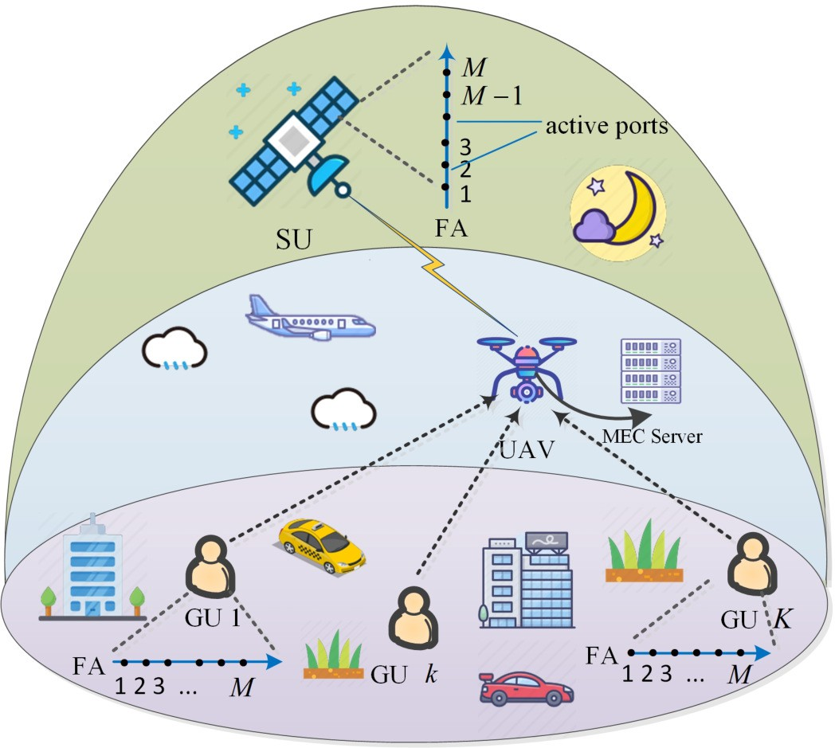

Fig. 1. Illustration of the FA-assisted MEC-SAGIN system, where K GUs and one SU offload their tasks to the edge computing node UAV via M-port FA.

offloading and CPU allocation subproblem, we first derive a closed-form solution for the task offload-ing variable, while the CPU allocation is solved by introducing auxiliary variables and applying successive
convex approximation (SCA). In addition, the UAV
ports, each of which can be activated if selected. The set of all GUs is denoted by K = {1, 2, . . . , K}, and the set of all FA ports at each GU or SU is denoted by M = {1, 2, . . . , M}. When transmitting signals, one port is selected for signal
transmission. Specifically, the index of the selected port can be represented by a variable r_{m} ∈ Z^{1×1}, where r_{m} ∈ M.

- Signal Transmission
The channel vector between each GU, SU, and UAV is determined by the propagation environment and the position of the UAV. It is assumed that the far-field condition is satisfied between the GUs and the UAV, as well as between the SU and the UAV.
We consider the transmission link from the GUs and the SU to the UAV. In the ground network, the coordinates of the kth GU can be denoted by v_{k} = (x_{k}, y_{k})^{T} since the height of each GU is approximated to be zero compared to the heights of the UAV and satellite. In the air network, we define the coordinates of the UAV as
q = (x, y)^{T} (1)
and the height of the UAV is denoted as H_{U} . Therefore, the distance between the UAV and the kth GU can be calculated as
q
q = lq − v l² + H2 . (2)
k
k
U

location optimization subproblem is also tackled using the SCA method. The receive beamforming subproblem is addressed via semidefinite relaxation (SDR) combined
Furthermore, the channel gain between the UAV and the kth GU can be expressed as

with Gaussian randomization, and the FA port selection subproblem is handled through a novel projected gradi-
h_{k} = β0
k
q
2
(3)

ent descent (PGD)-based approach to cope with integer constraints.
  - Simulation results demonstrate that the FA-assisted MEC-SAGIN system based on the proposed BCD algorithm achieves superior TCD performance com-pared with conventional FPA and random-port antenna schemes.
The structure of this article is as follows. In Section II, we establish the system model and formulate the TCD mini-mization problem. The solution to this problem is provided in
Section III. The simulation results are shown and discussed in
where β₀ is the path loss of the GU-to-UAV link at the reference distance of 1 m. In the space network, we denote the distance between the satellite and the UAV by d_{o}. Since the altitude of the satellite is very high, the positional change of the UAV has little effect on d_{o}. For simplification, we disregard the impact of the positional changes of the UAV on the distance between the satellite and the UAV. We model the SU-to-UAV wireless channel coefficient as
λo ₂
h_{o} = δ_{o}
(4)

4πd_{o}

Section IV. Finally, our conclusions are provided in Section V.

- System Model
As shown in Fig. 1, we consider a SAGIN system ori-
ented toward MEC tasks, comprising a satellite, a UAV, and
K GUs. The MEC tasks include computation tasks from GUs
where δ_{o} is the beam gain and λ_{o} denotes the wavelength of the SU-to-UAV transmission wave. The signal received at the UAV is formulated as follows:
y = X pp_{k}h_{k}g_{k} (r^{k} ) s_{k} + pp_{o}h_{o}g_{o} (rº ) s_{o} + n (5)
K
m
m
k=1

with insufficient computing capabilities and service tasks from the satellite user (SU). Specifically, the satellite continuously senses and collects data while moving along a fixed trajec-tory, transmitting the data to the UAV for computation and processing. Each GU and SU has a task to execute, which can be partially offloaded to the UAV and partially computed locally. The UAV is equipped with an MEC server and N FPAs, serving as an MEC node. In addition, we assume that each GU and SU is equipped with an FA consisting of M
where s_{k} ∈ C^{1×1} and s_{o} ∈ C^{1×1} denote the data stream variables from the kth GU and the SU, respectively, satisfying the distribution of zero mean and unit variance, p_{k} and
p_{o} denote the transmit power of the kth GU and the SU, respectively, and n ∼ CN (0, σ²I_{N} ) denotes the additive white Gaussian noise (AWGN). In addition, let g_{k}, g_{o} denote the multiple-access channel vectors from the kth GU and the SU to the UAV, respectively. A detailed description of the channel
models for g_{k} and g_{o} will be provided in Section II-B.

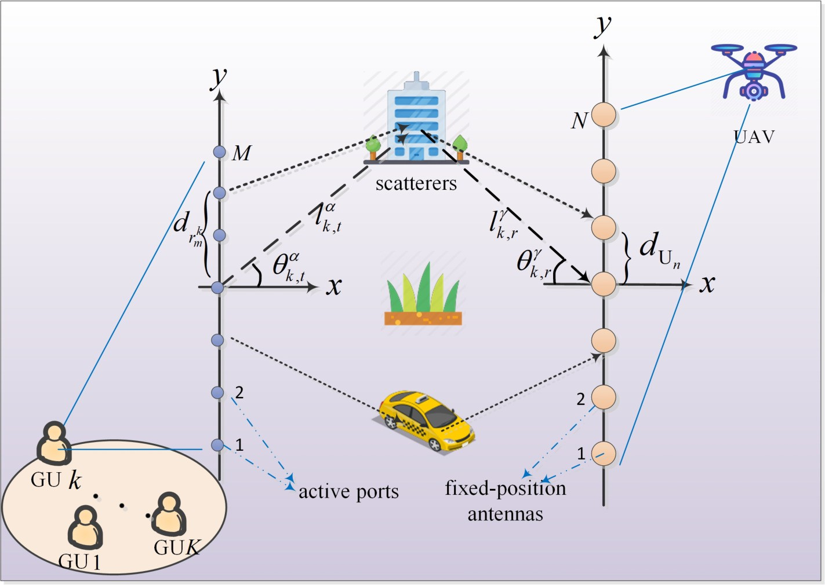
It is assumed that the linear equalizer vectors w_{k} ∈ C^{N×1}, ∀k ∈ K and w_{o} ∈ C^{N×1} are used to equalize the received signal of GUs and SU at the UAV, respectively. Thus, the
received signal of the kth GU and SU recovered at the UAV is, respectively, given by
sˆ_{k} = w^{H}y (6)
k
sˆ_{o} = w^{H}y. (7)
o
In addition, we employ orthogonal-frequency-division multiple access (OFDMA) for the GU-to-UAV communication, with the kth GU utilizing the frequency band B_{k}. Then the achievable transmission rate of the kth GU at the UAV is given by
p_{k}h_{k} ˇwH g_{k} (r^{k} )ˇ2 !
k
k
2
σ2 B_{k}
H 2
Fig. 2. Illustration of the coordinates for transmit and receive regions in the FA-assisted MEC-SAGIN system.
R
= B log
1 + k m
. (8)
ˇwk ˇ
The achievable transmission rate of the SU at the UAV is given by

p_{o}h_{o} ˇwH g_{o} (rº )ˇ2 !
H 2
R
= B log
1 + o m
o
o
2
σ2 B_{o}
ˇwo ˇ
and the coordinates of the nth receive antenna at the UAV as

2

where B_{o} represents the channel bandwidth of the SU. For tractability and fairness, we assume equal bandwidth allocation for all users.
(9)
2 (n − 1) − N + 1
d_{U}n =
d_{UAV} (13)

- Channel Model
In this section, we present a detailed explanation of the
where d_{FA} and d_{UAV}, respectively, represent the spacing between adjacent ports and adjacent FPAs.
Next, we derive the path difference in the transmission from GUs to the UAV, based on which the transmit field response vector u_{k}(r^{k} ) and the receive field response vector a_{k}(n) are formulated. Along the kth GU-to-UAV transmission link, let
m
l
k,r

multiple-access channel vectors g_{k} and g_{o}. For simplicity, the
α
k,t
and l^{γ}
denote the distances from the scatterer to the origin

numbers of transmit and receive paths are denoted by L_{t} and
L_{r}, respectively.
  - Channel Vector of the kth GU-to-UAV Transmission Link
g_{k}: We first provide the expression of g_{k}, which is given by
on the αth transmit path and the γth receive path, respectively. The propagation path difference between the position of the mth selected FA port and the origin is expressed as [39]
d² sin²θ^{α}
r
α
m
)

g (rk )
m

= A^{H}O u
(rk )

(10)
ρk,α (
k = −d_{r}k sinθk,t −
rk k,t
2l^{α}
. (14)

k m k k k m
m
k,t

where

A_{k} = [a_{k} (1) , a_{k} (2) , . . . , a_{k} (N)] ∈ C^{L}r×N (11)
Then, the propagation path difference between the position of the nth FPA at the UAV and the origin is given by [39]

represents the field response vectors of all the N receive antennas at the UAV and u represents the coe cients of
ρ_{k,γ} (n) = −d_{U} sinθ^{γ}
d 2 sin²θ^{γ}
− . (15)
Un k,r

_{k} ffi
n k,r
2l^{γ}

multipath responses from the kth GU to the reference point in the receive region. In addition, we define the path response
Herein, a_{k}(n) can be written as
k,r

matrix from the transmit FA port of the kth GU to the FPA of
UAV as O
∈ CL_{r}×L_{t} .
k
λ
λ
a (n) = he^{j} 2π ρk,1 (n), e ^{j} 2π ρk,2 (n), . . . , e ^{j} 2π ρk,L (n)iT ∈ C^{L}r×1 (16)

To further clarify the expressions of a_{k}(n) and u_{k}(r^{k} ), we next specify the angles involved in the transmission process and the distances between adjacent antennas and ports. Fig. 2 depicts the coordinates for the transmit and receive regions in an FA-assisted MEC-SAGIN system. The physical elevation
m
k
λ
r
and azimuth departure angles (AoDs) of the αth (0 ≤ α ≤ L_{t})
and the field-response vector of the mth FA at the kth GU is given by
k m
uk (r )
= hej 2π ρk,1 (rk ), e j 2π ρk,2 (rk ), . . . , e j 2π ρk,L (rk )iT ∈ CLt×1.
λ
m
λ
m
λ
t
m

transmit path from the selected port of the FA at the kth 2) Channel Vector of SU-to-UAV Transmission Link go:
GU to the scatterers are denoted by θ^{α} ∈ [−π/2, π/2] and Now we introduce the expression for g_{o} ∈ C^{N×1}, the multiple-
k,t

α
φ
k,t
∈ [0, 2π], respectively. In addition, the elevation and
access channel vector from the SU to the UAV, given by

azimuth arrival angles (AoAs) of the γth (0 ≤ γ ≤ L_{r}) receive
path from the scatterer to the received antenna at the UAV are
m
o
m
g_{o} (rº ) = A^{H}Ou_{o} (rº ) (17)

denoted by θ^{γ} ∈ [−π/2, π/2] and φ^{γ} ∈ [0, 2π], respectively.
k,r
k,r
where

For convenience, we define the coordinates of the mth transmit FA port at the kth GU as
2 (r^{k} − 1) − M + 1
m
A_{o} = [a_{o} (1) , a_{o} (2) , . . . , a_{o} (N)] ∈ C^{L}r×N (18)
represents the receive field response vectors of all the N

d_{r}k =
m
2 d_{FA} (12)
antennas at the UAV, u_{o} represents the coefficients of multipath

responses from the SU to the reference point in the receive region, and O ∈ C^{L}r×Lt represents the path response matrix from the SU to the UAV. Along the SU-to-UAV transmission
o,r
where T_{o} is the one-way propagation delay between the satellite and the UAV. The time delay for computing the task of the kth GU and SU at the UAV is given by

link, let l^{α}
o,t
and l^{γ}
denote the distances from the scatterer
l_{k}D_{k}C
t =
(26)

to the origin on the αth transmit path and the γth receive path, respectively. Similarly, the propagation path differences
between the position of the mth selected FA port of the SU and the origin, and between the position of the nth FPA at the
k,com

to,com =
f_{k}
lo DoC (27)
f_{o}

UAV and the origin, are denoted as

d² sin²θ^{α} t
m
−
where f_{k} and f_{o} represent the computation capability allocated
by the UAV to the kth GU and SU, respectively. Since the data size of the computation results is much smaller than that of the

and
m
m
ρo,α
(rº ) = −d_{r}o
sinθ
α
o,t
ro o,
α
2l
o,t

d² sin²θ^{γ}
−
(19)
offloaded computing data, the downlink transmission latency is negligible.

ρo,γ
(n) = −d_{U}n
sinθ^{γ}
Un o,r
γ
o,r
2l
o,r
(20)
D. Problem Formulation
In this work, we aim to minimize the maximum TCD

respectively [39]. Therefore, a_{o}(n) can be written as
of the proposed FA-assisted MEC-SAGIN system by jointly

h j 2π
a_{o} (n) =
e
_{λ} ρo,1
, e
_{λ} ρo,2
, . . . , e
ratio l = {l , {l }
}, the computing frequency assignment
(n)

j 2π
(n)

j 2π
(n)iT L 1
optimizing the UAV location q = (x, y)^{T} , the offloading

o
k k∈K

and the field response matrix corresponding to the activated
_{λ} ρo,Lr
∈ C r×
(21)
o
f = { f_{o}, { f_{k}}_{k∈K}}, the beamforming matrix W = {w_{o}, {w_{k}}_{k∈K}},
and the FA port selection variable r = {rº , {r^{k} }_{k∈K}}. The

port rm of the SU is given by m m 1
corresponding optimization problem is formulated as

uo (ro )
m
min T (28a)

= hej 2π ρo,1 (ro ), e j 2π ρo,2 (ro ), . . . , e j 2π ρo,L (ro )iT ∈ CLt×1.
λ
m
λ
m
λ
t
m

- Task Computing
In this section, we introduce the computing models of the system, including the local computing model and the edge computing model. Let l_{k}, l_{o}, C, D_{o}, and D_{k} denote the offloading ratio of the task for the kth GU, the offloading ratio of the task for the SU, the required CPU cycles for computing one bit of the tasks, the total computational task size of the SU, and the total computational task size of the kth GU, respectively. It is assumed that the task-input bits are bit-wise independent. Each GU and SU can perform part of its own computation task locally and upload the rest of the task to the UAV for calculation.
  - Local Computing: For local computing, the kth GU
q,l,f,W,r,T
T ≥ max ˚t_{k,loc}, t_{k,up} + t_{k,com} } ∀k (28c)
K
X
˚ }
s.t. T ≥ max
to,loc, to,up + to,com
(28b)
lw_{o}l² + lw_{k}l² ≤ P_{max} (28d)
k=1
0 ≤ l_{o} ≤ 1 (28e)
0 ≤ l_{k} ≤ 1 ∀k (28f)
0 ≤ f_{o} ≤ f_{total} (28g)
0 ≤ f_{k} ≤ f_{total} ∀k (28h)
K
X
f_{k} + f_{o} ≤ f_{total} (28i)
k=1
r^{k} ∈ M ∀k (28j)
m
rº ∈ M (28k)
m

calculates the total tasks of (1 − l_{k})D_{k} bits. Denoting the local
CPU frequency of the kth GU as f_{k,loc} Hz, the time required
where P

max
and f

total
represent the maximum transmission

for local computing is formulated as
power constraint and the maximum number of CPU cycles
for the UAV, respectively.

tk,loc
(1 − l_{k}) D_{k}C
= . (22)
f_{k}
,loc

- Algorithm Design

Moreover, SU calculates the total tasks of (1 − l_{o})D_{o} bits. Denoting the local CPU frequency of the SU as f_{o,loc} Hz, the time required for local computing is formulated as
Problem (28) is inherently nonconvex, and the optimization variables are intricately coupled, which poses significant chal-lenges for direct solution. To address this, we employ the BCD

to,loc =
(1 − l_{o}) D_{o}C fo,loc

. (23)
1To evaluate the lower bound on the total delay achievable by deploying FAs in the MEC-SAGIN system, we assume ideal FA port switching with zero switching delay in the theoretical analysis. Taking into account that

  - Edge Computing: The offloading time delay of the kth GU and SU to the UAV can be, respectively, expressed as
l_{k}D_{k}
each FA reconfiguration in a practical system incurs a nonzero delay, we further assume that the additional latency caused by FA switching can be upper-bounded as ∆T_{FA} ≤ N_{sw}τ_{switch}, where N_{sw} denotes the number of switching operations. Within the range of parameters under consideration,

tk,up =

to,up =
R_{k} l_{o}D_{o}
R_{o}
(24)

+ T_{o} (25)
the corresponding switching delay of this item is several orders of magnitude smaller than the communication and computing delays. Therefore, ignoring these switching terms does not affect the main conclusions of this work, while a more detailed hardware-aware modeling of switching losses will be pursued in our future investigation of robust FA system design.

method. This technique transforms the problem into a more
s.t. T ≥ max ˚t_{o,loc}, t_{o,up} + t_{o,com}, t_{k,loc}} ∀k (32b)

tractable form by decoupling the five optimization variables, allowing for an iterative solution. Specifically, we first update the UAV location q given the offloading ratio l, computing
Rˆk
≥ l_{k}D_{k}
T − l_{k} D_{k}C
f
k
∀k (32c)

frequency assignment f, the equalizer matrix W, and the FA port selection r. Second, we update the offloading ratio l and computing frequency assignment f given W, q, and r. Then, we optimize the receiver beamforming W given l, f, q and r. Finally, the FA ports r are updated given W, l, f, and
q. Repeat the above process until convergence.

- UAV Location Optimization
Given the variables l, W, r, and f, Problem (28) for UAV location design can be simplified to
which is convex and can thus be efficiently solved by utilizing
convex optimization software.

- Offloading Volume and Computing Frequency Optimization
For any given q, W, r, the offloading volume of the users’ tasks and the computing frequency assignment at the UAV of Problem (28) can be optimized by solving the following problem:
min T
l,f

min
q,T
T (29a)
s.t. (28b), (28c), (28e), (28f), (28g), (28h), (28i). (33)

s.t. T ≥ max ˚to,loc, to,up + to,com, tk,loc} ∀k (29b) Since Problem (33) remains intractable, we perform alternating
T ≥ l_{k}D_{k} + l_{k}D_{k}C ∀k. (29c) optimization of l and f, as detailed below.

R_{k} f_{k}
Then, we can transform the constraint (29c) as follows:
l D
  - Offloading Volume Optimization: Obviously, Problem
(33) is a linear optimization problem with respect to l, and
therefore we have

Rk ≥ k k
T − l_{k} D_{k}C
∀k. (30)
T_{i} = max ˚t_{i,loc}
, ti,up
+ ti,com
} , i ∈ K ∪ {o}

fk (1 − l_{i}) D_{i}C
8ˆ
,

Note that Problem (29) is nonconvex due to the nonconvexity
(
of the logarithm terms in R_{k}. To resolve this issue, the
fi,loc
ˆ
=
(D C − f
T ) R f

denominator of R
D_{i}
CRi fi + fi fi,loc + CRi fi,loc
can be e
ciently transformed using the
ˆˆ<
0 ≤ l_{i} ≤ i
i,loc i i i
)
(34)

SCA method. R_{k} can be expressed in a convex form with
k
ffi
respect to lq − v_{k}l², since the function log(1 + a/(b + x)) is
l_{i}D_{i}

ˆ
+ T_{i} +
l_{i}D_{i}C
f ,

convex in x for positive constants a and b. According to the properties of convex functions, the first-order Taylor expansion
at any point provides a global lower bound, which ensures that
^{i} D C −i f
ˆ: (
R
D_{i}
CRi fi + fi fi,loc + CRi fi,loc
i
i,locTi) Ri fi

) ≤ _{i}
l ≤ 1

the approximated problem remains tractable while maintaining where Ti = 0, ∀i ∈ K. Then, the offloading vector lopt is given solution quality. Then, let q( j) = {x⁽ ^{j)}, y⁽ ^{j)}}^{T} denote the UAV by
ˆ (

location in the jth iteration. We derive the lower bound of R_{k}
as follows:

lopt=
(DiC − fi,locTi) Ri fi

∀i ∈ K ∪ {o} . (35)

i D (CR f + f f + CR f )
ˇ H ˇ2 ! i i i i i,loc i i,loc
R = B log 1 + pkhk ˇwk gk ˇ

k k 2
ˇw ˇ
σ2 B_{k}
H 2
p_{k}β₀ ˇw g_{k}ˇ !
H 2
1 + k
k

Algorithm 1 Joint Optimization of l and f Given r, W, and q
1: Initialize the accuracy E, the iteration index j = 0, the
(0)

k 2 2 (lq − v l² + H2 )
= B log
σ2 B ˇwH ˇ
maximum number of iterations j_{max}, set feasible f .

k k
k
U
0 p_{k}β₀ ˇw g_{k}ˇ 1
H 2
k
2: Calculate l( j) using (35).
3: With l( j), calculate f( j) by solving Problem (40).

≥ Bk log2 @1 + 2 ˇ H ˇ2 (1 ( j) 1 2 A 4: If j > j_{max} or the objective function converges |T ⁽ ^{j+1)} −
2

σ B_{k} wk
0
B C
+ B_{k}
1 1
q − v_{k}
+ HU
1
T ⁽ ^{j)}|/|T ⁽ ^{j+1)}| < E, terminate and output lopt and fopt. Otherwise, set j ← j + 1 and go to step 2.

In2 p β |w g |
@ 1 + k 0 k k A
H
2
σ2 Bk |wH |2 (lq( j) −vk l2 +H2
k
U

l = lopt, the subproblem of f can be rewritten as follows:

p_{k}β₀ ˇwH g_{k}ˇ2 ! lq − v_{k}l² − 1q( j) − v_{k}12
2) Computing Frequency Optimization: Given q, W, r, and
− ^{k} = Rˆ .
CR f + f f
+ CR f
(31)
s.t. (28g), (28h), (28i). (36)
It is observed that Problem (36) is nonconvex. By introducing

min

max
(D_{i} f_{i} + D_{i}CR_{i} + T_{i}R_{i} f_{i}) C

σ2 B
H 2
2
×
k
k
q
− v_{k}
+ HU
ˇw ˇ
(1 ( j) 1
2 ₂ k
f i∈K∪{o}
i i i i,loc
i i,loc

Then, Problem (29) can be reformulated as the auxiliary variable ξ, Problem (36) is formulated as

min
q,T
T (32a)
min
f,ξ
ξ (37a)

s.t. ξ≥ (Di fi + DiCRi + TiRi fi) C , i ∈ K ∪ {o}
CRi fi + fi fi,loc + CRi fi,loc
(28g), (28h), (28i). (37b)
1 + i

The achievable transmission rate of the GUs and SU at the UAV is equivalently expressed as

Considering that both the numerator and the denominator in constraint (37b) contain f_{i}, we introduce auxiliary variables
e = {e_{i}, i ∈ K ∪ {o}} and m = {m_{i}, i ∈ K ∪ {o}}, then constraint

i i 2
R
= B log
= B_{i}log2
p_{i}h_{i}
w_{i} g_{i}
+σ B_{k}
i
( σ B_{i} ˇw ˇ

ˇ H ˇ2
2 H 2
w_{i}

(37b) can be reformulated as follows:
2
p_{i}h_{i} ˇwH g_{i}ˇ2 !
H 2
− B log (σ²B ˇw^{H}ˇ2

ei ≤ CR_{i} + f_{i,loc} + fi (38a)
CD_{i} + CT_{i}R_{i}
CRi fi,loc
i
2
i
i
ˇ ˇ
CD CR
= B_{i}log2 (tr (Hˆ iWˆ i)) − B_{i}log2 (tr (H˜ iWˆ i))

i i ≤ f_{i} (CR_{i} + f_{i,loc}) + CR_{i} f_{i,loc} (38b)
m_{i}

where
i ∈ K ∪ {o}

e_{i} + m_{i} ≤ ξ. (38c)
H p_{i}h_{i}g_{i}gH +σ²B_{i} 0_{N×1} l

(N 1)×(N 1)

Since constraint (38a) remains nonconvex, we use the SCA method to further transform the constraint into a convex form

and
ˆ i =
i
01×N
01×1
∈ C + +
(46)

as follows:

CD_{i} + CT_{i}R_{i}
H˜ σ2 BiIN 0N×1 l

(N 1)×(N 1)
+
+
. (47)

ei Then, constraint (44) can be transformed into
_{i} =
0
1×N
0
1×1.
∈ C

≤ CRi + fi loc + CRi fi,loc − CRi fi,loc ( fi − f ( j) (39)
f
f
,
( j)
i
( j),2
i
i

where f ⁽ ^{j)} represents the solution obtained from the previous iteration. Then, Problem (36) can be converted to a convex problem which is given by
i
min ξ
f,e,m,ξ
( li D( i )) ( ( ))
T − Ti − li DiC
f_{i}
B_{i}log2
tr
Hˆ iWˆ i
− B_{i}log2
tr
H˜ iWˆ i
≥ . (48)
Similarly, constraint (28d) is equivalent to
tr (Wˆ o) + X tr (Wˆ k ) − (K + 1) ≤ P_{max}. (49)
K

s.t. (28g), (28h), (28i), (38b), (38c), (39). (40)
Therefore, Problem (40) can be solved by standard convex solver packages, such as CVX. The procedure of solving Problem (33) is summarized in Algorithm 1.
k=1
To convexify B_{i}log2(tr(H˜ iWˆ i)), we apply the SCA approach to constraint (48). It can be rewritten as
B_{i}log2 (tr (Hˆ iWˆ i))

≥ li Di + B_{i}log
f_{i}
C. Receive Beamforming Optimization
T − Ti − li DiC
2
i
(tr (H˜ iWˆ ( j)

Given the UAV location q, the offloading ratio l, the
B 1 tr 0@ H˜ i
(Wˆ − Wˆ ( j) 1A . (50)

computing frequency assignment f, and the FA port selection
i
i
variable r, Problem (28) can be transformed to

+ i In2
tr (H˜ Wˆ ( j) i i

min T
W,T
Therefore, Problem (41) can be recast as follows:

s.t. (28b), (28c), (28d). (41)
min
Wˆ ,T
T (51a)

To tackle Problem (41), constraints (28b) and (28c) can be simplified to
s.t. (42), (49), (50)
Wˆ i [N + 1, N + 1] = 1 (51b)

T ≥ max ˚t

k,loc

, to,loc
} (42)
Wˆ i 0, rank (Wˆ i) = 1. (51c)

T ≥ li Di + T_{i}
R_{i}
l_{i}D_{i}C
+ fi , i ∈ K ∪ {o} (43)
By dropping the rank-one constraint, Problem (51) is a standard semidefinite programming problem which can

where T_{i}
as
= 0, ∀i ∈ K. Constraint (43) can be further written
R l_{i}D_{i}
−
be solved using CVX. Then, we can use the Gaussian
randomization method to recover the optimal rank-one solution.
ˆ 1

^{i} ≥ T − T
i
li DiC . (44)
f_{i}
We denote Wi as the rank-one relaxed solution to Problem (51), Σ as a diagonal matrix including the eigenvalues of Wˆ 1,

and Wˆ 1 = UΣUH as the eigenvalue decomposition of Wˆ 1,
i

To solve this nonconvex problem, the SDR method is applied. i
ˆ 1 i

We define
where the columns of U are eigenvectors of Wi . Specifi-

cally, we generate 10 000 random candidate vectors, that is,
w

Wˆ i
= wi l wH1 ∈ C^{(N+1)×(N+1)}, i ∈ K ∪ {o} . (45)
( j)
i
= (UΣ^{1/2}τ ^{j})/([UΣ^{1/2}τ ^{j}]_{N+1}), j = 1, 2, . . . , 10 000, where

1 τ ^{j} represents a unit vector and follows τ ^{j} ∼ CN (0, I_{N+1}).
i

Then, Wˆ opt satisfies all the constraints in Problem (51) and for the GD method, respectively. Next, we carry out a detailed
i i i
the objective function T is selected as the minimum solution. derivation for ∇ri,( j) f (rm). Using the chain rule, ∇_{r}i f (rm) can

Then, we have w^{opt} = [w⁽ ^{j),∗}]
. To ensure the convergence
m m
be expressed as

i i 1:N

of the algorithm, extensive Gaussian randomization can be performed.
m
m
∂ f (r )

- FA Ports Optimization

where

∇_{r}i f
(ri ) =

i m
∂R_{i}
∂R_{i}
· ∂ri
m

, i ∈ K ∪ {o} (56)

In this part, we optimize the position of FAs at the users, that is, r, to minimize the total tasks computation delay subject to the positive integer constraints of the acti-
i
^{m} = −
∂ f (r )
∂R_{i}
l_{i}D_{i}

2
i
R

(57)

vated ports. Then, the optimization problem is formulated as follows:
ˇ
σ B
wi
2
∂R_{i} B_{i} 0B 1 1C
p_{i}h_{i}

∂r^{i} In2 @ 1 + pihi |wH gi (ri )| A 2 i ˇ H
i
∂ ˇw g_{i} (r )ˇ
m
i
m
min
T (52a)
σ2 B_{i}|wH |2
=
2

r,T
s.t. T ≥ max
˚tk,loc, to,loc}
∀k (52b)
H i 2
× ^{i} ^{m} . (58)
∂ri

l_{i}D_{i}
T ≥ Ri + T_{i} +
li DiC , i ∈ K ∪ {o}
f_{i}
m
Based on (58), it is important to derive the closed-form
expression of (∂|wH g_{i}(r^{i} )|²)/(∂r^{i} ), i ∈ K ∪ {o}. Then, we

where
∂ri
∂ri
m
m
(28j), (28k) (52c)
have
i m m

( ) !
p_{i}h_{i}|wH g_{i}
ri
|2
R
= B log
1 + i m
∂ ˇw^{H}g_{i} (r^{i} )ˇ2 ∂wH ( ) ( )H
m
m

σ B_{i}|wi |
i m = i gi
ri
g_{i}
ri
w_{i}
i
i
2
2
H 2
∂ (g (r^{i} ) g (r^{i} )H

i

and (52c), it is not feasible to solve this problem directly via m w
i
, i ∈ K ∪ {o} . (53)
Due to the integer nonconvexity of constraints (28j), (28k),
+ w^{H}
i
m
∂ri
i
m
w
∂ri

standard convex optimization techniques. Referring to [40],
gradient descent (GD) presumes a continuous, differentiable
i
m
m
+ w^{H}g_{i} (r^{i} ) g_{i} (r^{i} )H ∂ i

domain and is largely agnostic to curvature, so it is mainly suitable for smooth problems with simple constraints. In contrast, FA port selection is discrete and integer-constrained.

= w^{H}
i
i i H
m m
m
m
∂ (g_{i} (r ) g_{i} (r )

∂ri

w_{i}. (59)

A relax-and-round GD approach often produces infeasible or oscillatory iterates and offers no monotone-descent guarantee under the coupled SINR constraints. Thus, we adopt a PGD
algorithm to solve the FA port selection subproblem. In each
Since the beamforming vector w_{i} is optimized in a separate subproblem given the FA port selection r^{i} , it can be treated as a constant during the gradient computation with respect to r^{i} , that is, (∂w_{i})/(∂r^{i} ) = 0. This simplifies the chain

m m
m

iteration, we first optimize a virtual continuous port index. We then use a projection step to map this index to the nearest feasible discrete port. This two-step approach enforces integer feasibility without exhaustive search, guaranteeing convergence to a locally optimal solution of Problem (52). For tractability, constraint (52b) is treated as a constant upper
rule differentiation process and enables efficient gradient-based optimization. For simplicity, we denote g_{i}(r^{i} )g_{i}(r^{i} )^{H} = G_{i} ∈ C^{N×N} , where
G_{i} = A^{H}O_{i}u_{i} r^{i} A^{H}O_{i}u_{i} r^{i} ^{H} . (60) Since A_{i} and O_{i} are independent of r^{i} , it is only necessary
i
m
i
m
m m
( ( )) ( ( ))

bound on the feasible region and is therefore omitted during
to di
m
i i H i

the PGD updates. We further relax the discrete design by
fferentiate u_{i}(rm)u_{i}(rm) with respect to rm. Then, we can

denote u_{i}(r^{i} )u_{i}(r^{i} )^{H} = U_{i} and derive U_{i} as shown in (65),
allowing a continuum of virtual ports and enforcing the m m

fact that only M ports can be activated via the projection step.
Specifically, denoting f (r^{i} ) = (l_{i}D_{i})/(R_{i}) + T_{i} +
as shown at the bottom of the next page. Based on (65), the element in the xth row and yth column of U_{i} can be rewritten as

m
[U ]
= e j 2π (ρi,x (ri )−ρi,y (ri )). (61)

(l_{i}D_{i}C)/( f_{i}), i ∈ K ∪ {o}, the update rule of the PGD method for r is given by
r^{i,(} ^{j+1)} = r^{i,(} ^{j)} − µ∇ri,( j) f (r^{i} ) , i ∈ K ∪ {o} (54)
m
m
m
m

i x,y ^{λ} ^{m} ^{m}
Now we take the derivative of each element in U_{i} with respect to r^{i} as follows:
m
i x,y
∂ri

r^{i,(} ^{j+1)} = N ˚r^{i,(} ^{j+1)}, M} , i ∈ K ∪ {o} (55)
m
m
∂ [U ]

where (54) represents the updated r_{m} value in the ( j + 1)th iteration of the GD method and (55) ensures that the FA port solution in each iteration always satisfies the integer constraint
i,( j+1)
m
= ∂ e j 2π (ρi,x (ri )−ρi,y (ri ))
λ m m
∂ri
m
· j λ ∂ri
ρi,x
rm
− ρi,y
rm
. (62)

r m λ i
= e
i 2π ∂

through the projection function N {·}. In addition, ∇ i,( j) f (r^{i} )
i
i,( j)
m
and µ denote the gradient of f (rm) at r_{m} and the step size
j 2π (ρi,x (rm )−ρi,y (rm )) (
m
( _{i} )
( _{i} ))

Based on (14), we derive the result for (∂ρ_{i,α}(r^{i} ))/(∂r^{i} ) as F. Complexity and Convergence Analysis

follows:

∂ρ_{i,α} (r^{i} )
∂ri

∂d_{r}i

sin² θ^{α}
m m

∂d²
r
^{m} = − sin θ^{α} · m − ^{i,t} ·
i
m
The overall algorithm for solving Problem (28) is summa-rized in Algorithm 3.

i,t
m m t m
∂ri
2l^{α}
∂ri
sin² θ^{α}
α i,t
= − sin θ · d_{FA} − d_{r}i · d_{FA}. (63)
Algorithm 2 Feasible Step Size Selection in the PGD Method for Solving Problem (52)

i,t α _{m}
l
t

1: Initialize the step µ > 0 and the initial point r(0) of the
2: Calculate r = N {r −µ∇ i,( j) f (r ), M}, i ∈ K ∪{o}.

Thus, we have
∂ (ρi x (ri ) − ρi y (ri ))
∂ri
,
m
,
m
m
PGD method. Set the iteration index j = 1, w ∈ (0, 0.5) and ϕ ∈ (0, 1).

( ) sin² θ^{x} sin² θ^{y} ! 3: If f (r ) > f (r ) − wµl∇ i,( j) f (r )l , update µ ← ϕµ.
i,( j+1) i,( j) i
i,( j+1) i,( j) i 2
m
m
r_{m}
m
x
y
i,t
i,t
m
m
r_{m}
m
= −d_{FA}
sin θi,t − sin θi,t
−d_{FA} · d_{r}i
lx
−
ly
.
Otherwise, set j ← j + 1 and go to step 2.
m
t t
(64)

Finally, by substituting (64) into (62), then substituting (62) into (59), the gradient (∂|wH g_{i}(r^{i} )|²)/(∂r^{i} ) at r^{i} can be computed as in (67), as shown at the bottom of the page. Therefore, ∇ri,( j) f (r^{i} ) can be derived as (68), shown at the bottom of the page.
_{m} m
i m m m
- Projection Function N {·} and Feasible Step Size
The projection function primarily ensures that FA ports are selected only within respective feasible regions. Given the assumption of virtually selectable points in the GD method, the projection function can thus be defined according to the nearest distance criterion as follows:
N ˚r^{i,(} ^{j+1)}, M} t> r^{i,(} ^{j+1)} = min (max ((r^{i,(} ^{j+1)}r, 1) , M) (69)
m
m
m
  - Complexity Analysis: We evaluate algorithmic complex-
ity using the total count of floating-point operations, treating each addition or multiplication as one flop. The complexity is expressed with respect to the sizes of the matrices involved, and subsequently simplified by keeping only the dominant highest-order terms and omitting the remainder.
The proposed BCD algorithm jointly optimizes five vari-ables with the following computational complexities. For UAV location optimization, the SCA method solves a convex problem with N_{q} iterations, yielding complexity O(N_{q} · n^{3.5}). The task offloading ratio optimization admits a closed-form solution given by (35), requiring only O(K + 1) opera-tions. For computational frequency allocation, the SCA-based approach requires N iterations to solve a convex problem with
q
f

where Lxl represents the rounding of x to the nearest integer. In addition, referring to [41], we use the backtracking line
search (BLS) method to determine the step size for the PGD method, as detailed in Algorithm 2.
3(K + 1) + 1 variables, resulting in complexity O(N_{f} (K +
- ³). The receive beamforming optimization dominates the
computational burden, where solving the SDP formulation with (K + 1) matrices of size (N + 1) × (N + 1) requires

e λ · · · e λ
e
λ
m
m
λ
m
m
λ
m
t
m
j 2π (ρi,2 (ri )−ρi,1 (ri ))
j 2π (ρi,2 (ri )−ρi,2 (ri ))
j 2π (ρi,2 (ri )−ρi,L (ri ))
2 e j 2π (ρi,1 (ri )−ρi,1 (ri )) e j 2π (ρi,1 (ri )−ρi,2 (ri )) · · · e j 2π (ρi,1 (ri )−ρi,L (ri )) 3
λ
7
u ( i ) u ( i )H 6 m m m m m t m
i
r
m
i
rm
=
64
.
.
. . . .
75
(65)

e j 2π (ρi,L (ri )−ρi,1 (ri )) e j 2π (ρi,L (ri )−ρi,2 (ri )) · · · e j 2π (ρi,L (ri )−ρi,L (ri ))
x
· j
−d_{FA}
sin θi,t − sin θi,t

∂ [U_{i}]_{x} _{y}
m
,
∂ri
l

λ t m

2 i
j π (ρi,x (rm )−ρi,y (rm ))
= e
λ
y i,t

m λ t m m i 2π (

λ t m
i,t
)
y
− d_{FA} · d_{r}i
t m

sin² θ^{x}
i,t
l
x i,t

m

sin² θ^{y} !!

∂[Ui ]1,1
2
λ
−
(66)
∂ri
∂[Ui ]1,2
∂ri
· · · ∂[Ui ]1,Lt 3

ˇ _{H} (
_{i} )ˇ₂
m
∂[Ui ]2,1
6
m
m
∂[Ui ]2,2
m
∂[U_{i}]_{2,L}t

∂ ˇwi g_{i}
rm ˇ
= w^{H}A^{H}O
∂ri
∂ri
· · ·

∂ri
7
∂ri
m
m
7
.
O^{H}A w , i ∈ K ∪ {o} (67)

∂ri
i i i .
4
m
∂[U_{i}]_{L}t ,1
∂ri
6
.
. . . .
. 75
i i i

∇ i ( j) f (r^{i} ) = − ^{i} ^{i} · ^{i} 0B 1 1C pihi
6
m
m
∂ri
l D B
∂[U_{i}]_{L}t ,2
∂ri
· · · ∂[Ui ]Lt ,Lt .
m
L_{t}×L_{t}
.
r , m R2 In2 @ p h |w^{H} g (r )|2 A 2 H 2
ˇ
2
m
i
1 +
i i
i
i
i m
σ B_{i}
w
i
σ2 B_{i}|wH |2
ˇ
2

∂[Ui ]1,1
∂ri
i
∂[Ui ]1,2
∂ri
· · · ∂[Ui ]1,Lt 3 3

m
∂[Ui ]2,1
6
m
m
6
.
7
m
∂[Ui ]2,2
.
· · ·
∂[U_{i}]_{2,L}t

× w^{H}A^{H}O
6 6
∂ri
∂ri
∂ri
7
∂ri
m
m
7
· · · ∂[Ui ]Lt ,Lt .
m
m
7
7
.

O^{H}A w
(68)

64 64 .
∂[U_{i}]_{L}t ,1
∂ri
m
i
i
i
. . . .
∂[U_{i}]_{L}t ,2
∂ri
. 75
∂ri
i i i
5
i
i,( j)
L_{t}×L_{t}
rm =r_{m}

O(N_{w}((K + 1)(N + 1)²)^{4.5}), and subsequent Gaussian random-ization with N_{rand} = 10,000 samples adds O(N_{rand}(K + 1)N²), making the total beamforming complexity O(N_{w}(K +1)^{4.5}(N + 1)⁹). Finally, the FA port selection optimization employs PGD
with BLS, where each of N_{pgd} iterations involves gradient computation at complexity O((K +1)L²N) and N_{bls} line search steps, yielding total complexity O(N_{pgd}(N_{bls}(K + 1) + (K +
t
- L²N)). With N_{BCD} outer iterations, the overall algorithm
and K = {1, . . . , K}. Each user (GU/SU) employs an FA with M selectable ports M = {1, . . . , M} and only one port is active per transmission. The uth UAV is at q_{u} = (x_{u}, y_{u})^{T} with altitude
H_{U}. Large-scale loss and multipath vectors follow the original definitions, now indexed by u. The distance between the UAV u and the kth GU can be calculated as
q 2 2 2
qk,u =
lq_{u} − v_{k}l
+ HU, h_{k,u} = β₀/qk,u. (70)

complexity is O(N_{BCD} · max{N_{q}, N_{f} (K + 1)³, N_{w}(K + 1)^{4.5}(N +
t
In addition, the user-to-UAV channel vectors can be rewritten

- ⁹, N_{pgd}N_{bls}(K + 1)L²N}). _{k} _{o}

t
Algorithm 3 Task Computation Delay Minimization Algo-
as g_{k,u}(rm) and g_{o,u}(rm).
  - Signal Transmission: At UAV u, the received signal is

rithm for the FA-Assisted MEC-SAGIN System
m
y_{u} = X
ppkhk,u gk,u (rk ) sk

1: Initialization: Let q(0) = ¹ Pk
q
v , ri,(0) =
k∈K∩S_{u}

arg max
max
m∈M
K+1 lg (r^{i,(0)})l
| wH g (m) |², w⁽⁰⁾
K ∈K
= P
k
g (ri,(0))
i
m
m
, l(0) =
i
+ X pp_{o}h_{o} _{u} g_{o} _{u} (rº ) s_{o} + n_{u} (71)

- (D C− f
b
i
i
i
i
, f
Di(CR(0) f (0) + f (0) fi,loc+CR(0) fi,loc)
total
set the
iiteratiion indeix k = 10.

i

T ) R(0) f (0) i1
(0)
i

- m 2

= f
/(K + 1), and

o∈O∩S_{u}

where n_{u} ∼ CN (0, σ I_{N} ) and S_{u} is the set served by UAV u.

2: With given l(k−1), f(k−1), W(k−1), r(k−1), solve the UAV loca-
i,loc i
i
i
2
With OFDMA per UAV, the rate of user i ∈ K ∪ O at UAV u
is

tion subproblem and obtain q(k).
R
= B
log
1 + i i,u i,u i,u m
(72)
1w
1
3: With given q(k), W(k−1), r(k−1), solve the joint offloading

p h ˇwH g
i,u
i,u
2
σ2 Bi,u

(ri )ˇ2 !

i,u
2

lem and obtain l(k) and f(k).
volume and computing frequency optimization subprob-
4: With given l(k), f(k), q(k), r(k−1), solve the receive beam-forming subproblem and obtain W(k).
with linear equalizer w
budget as follows:

i,u
∈ C^{N×1} and per-UAV bandwidth

5: With given l(k), f(k), q(k), W(k), solve the FA port selection subproblem and obtain r(k).
i∈XK∪O
B_{i,u} ≤ B^{(u)}
∀u. (73)

6: If the objective of Problem (28) converges, output
total
(q(k), l(k), f(k), W(k), r(k)); otherwise set k ← k + 1 and go
to Step 2.
Moreover, for each user, only one FA port is active per transmission, that is, r^{i} ∈ M and exactly one m is selected.

  - Convergence Analysis: In this section, we analyze the convergence of Algorithm 3. We denote the TCD objective function as F(q, l, f, W, r). In the kth iteration, we have
m
- Task Computing: Let a_{i,u} ∈ {0, 1} denote the association indicator, where each task is handled by exactly one UAV, that is, u∈U a_{i,u} = 1. With offloading ratio l_{i} ∈ [0, 1], the edge computing time delays are given by

F (q(k) l(k) f(k) W(k) r(k))
P
,
,
,
,
u
,
,
ti up = X ai u li Di + 1 i
X a_{i} _{u}T_{i} _{u} (74)

≥ F (q(k+1), l(k), f(k), W(k), r(k))
(a)
- ( (k+1) (k+1) (k+1) (k) (k))
≥ F q , l , f , W , r

ti,com

= ai,u
X
,
u
,
Ri,u
∈O
u
l_{i}D_{i}C fi,u
(75)

- ( (k+1) (k+1) (k+1) (k+1) (k))
≥ F q , l , f , W , r
- ( (k+1) (k+1) (k+1) (k+1) (k+1))
≥ F q , l , f , W , r
and the per-UAV CPU constraint is
(u) total
X f_{i,u} ≤ f
i∈S_{u}

∀u. (76)

where (a), (b), and (c) hold because (32), (35), (40), and (51) are the optimal solutions of the corresponding subproblems.
(d) holds because the monotonic decrease and boundedness of the objective sequence f (r^{k} ), together with the Lipschitz
m
- Problem Formulation: In this work, we aim to minimize the TCD of the proposed FA-assisted MEC-SAGIN system with multiple UAVs and SUs. The corresponding optimization problem is formulated as

continuity of the gradient, ensure that PGD with Armijo back-tracking converges to a first-order stationary point. Moreover, with the bounded feasible set in Problem (28), the objective
function has a finite lower bound. Hence, Problem (28) is
min
{q_{u}}, {l_{i}}, { f_{i,u}},
{wi,u },{ri }, {ai,u },
m
{Bi,u }, T
X a_{i,u} = 1, a_{i,u} ∈ {0, 1} ∀i (77c)
T (77a)

guaranteed to converge.

G. Extended System Model With Multiple UAVs and Multiple SUs
s.t. T ≥ max ˚t_{i,loc}, t_{i,up} +t_{i,com}} ∀i (77b)

u
0 ≤ l_{i} ≤ 1 ∀i (77d)
X f_{i,u} ≤ f

To demonstrate scalability, we extend the system to U
,
,
m
UAVs, O SUs, and K GUs. Let U = {1, . . . , U}, O = {1, . . . , O},
(u) total
i∈S_{u}
(77e)

(u) total
X B_{i,u} ≤ B
i∈S_{u}
∀u (77f)
TABLE I
Default Simulation Parameter Settings

B_{i,u} ≥ 0, r^{i} ∈ M ∀i, u (77g)
m
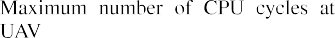
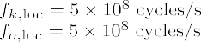
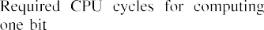

X 1w_{i,u}12 ≤ P^{(u)} . (77h)
max

i∈S_{u}
It is observed that the extended multi-UAV and SUs problem is nonconvex due to the coupling among association, bandwidth, CPU allocation, FA-port selection, receiver design, and UAV locations. To address this, we adopt an alternating optimization framework that iteratively solves the following subproblems.
- Receiver Beamforming Optimization: Given
{r, l, f, B, q, A}, Problem (77) is reduced to a receiver beamforming optimization subproblem. By using the SCA method, the W subproblem can be reduced to an
SDR convex problem, which can be solved by CVX and then recovered by Gaussian randomization.
- UAV Location Optimization: Given {r, l, f, B, W, A}, Problem (77) is reduced to a UAV location subproblem.
Due to the nonconvexity of R_{k}, we can utilize the SCA method adopted in Problem (77) to rewrite R_{k} by its first-order Taylor expression and solve the transformed convex problem iteratively to obtain the optimal UAV location.
- Offloading Volume and Computing Frequency Assign-ment Optimization: Given {r, q, B, W, A}, the optimal CPU frequency f and offloading volume l can be jointly optimized by the SCA method and then we can obtain the closed-form solutions for l.
- Per-UAV Bandwidth Allocation Optimization: Given
{r, l, f, q, W, A}, the per-UAV bandwidths are updated under individual bandwidth budgets via a first-order SCA that convexifies the nonconvex rate expressions
around the previous iterate, yielding a convex program solved efficiently.
- User-to-UAV Association Optimization: Given
{r, l, f, q, W, B}, we first relax the A-subproblem to a continuous formulation and then solve it using a greedy algorithm or the Hungarian method.

- Simulation Results
In this section, we conduct experiments to evaluate the TCD performance of the FA-assisted MEC-SAGIN system and validate the effectiveness of our proposed algorithms. We consider three GUs and an SU, where the GUs are uniformly distributed within a circular area centered at (50,0) with a radius of 50 meters. The main simulation parameters are listed in Table I.²
The following provides a detailed introduction to our simu-lation results. To clearly demonstrate the effectiveness of our proposed FA-assisted MEC-SAGIN design, we provide the following benchmark schemes.

2The simulation parameters in Table I are selected based on practical system specifications and validated against existing literature [5], [6], [7], [16], [17],
[18], [22], [25], [26], [27], [28]. These parameter choices ensure the simulation reflects realistic deployment scenarios.

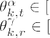

- Conventional FPAs: Both the GUs and the SU are equipped with FPAs, with each user having M FPAs for signal transmission, spaced by d_{FA}(M − 1).
- Random FAs: The activated ports of the FA at the GUs
and SU are randomly selected, and other variables are optimized using the proposed algorithm.
- Proposed FAs (Exhaustive Method): The FA port selec-tion variables of GUs and SU are optimized using the exhaustive search method, while the other variables are optimized using the proposed algorithm.
- Hybrid FAs: In this scheme, the users’ antennas operate in the FPA mode for half of the transmission time and in the FA mode for the other half.
- Proposed FAs (Penalty-Based Algorithm): The receive beamforming is optimized by the penalty algorithm, and the other variables are optimized using our proposed algorithm.
- Fixed UAV Location With FAs: The UAV is fixed at the initial position, while FA port selection and MEC resource allocation are optimized by our proposed algorithm.
Based on the six proposed schemes, we further evaluate the convergence performance of our proposed algorithm, the impact of the number of FA ports, and the TCD performance with respect to the total edge computing resource, user task size, number of edge computing users, number of channel paths, and FA port spacing.
We first evaluate the convergence performance of the BCD algorithm under different numbers of FA ports in Fig. 3. It can be observed that the TCD decreases monotonically as the number of iterations increases. The proposed algorithm converges within five iterations, underscoring its effectiveness and low computational complexity.
Fig. 4 illustrates the impact of the number of FA ports on the TCD performance under different algorithms. Except for the conventional FPAs approach, the TCD of all FA-based algorithms exhibits a decreasing trend as M increases, owing to the enhanced degrees of freedom that contribute to reducing the overall completion time of edge computing tasks. However, as the number of antenna ports surpasses M > 10,

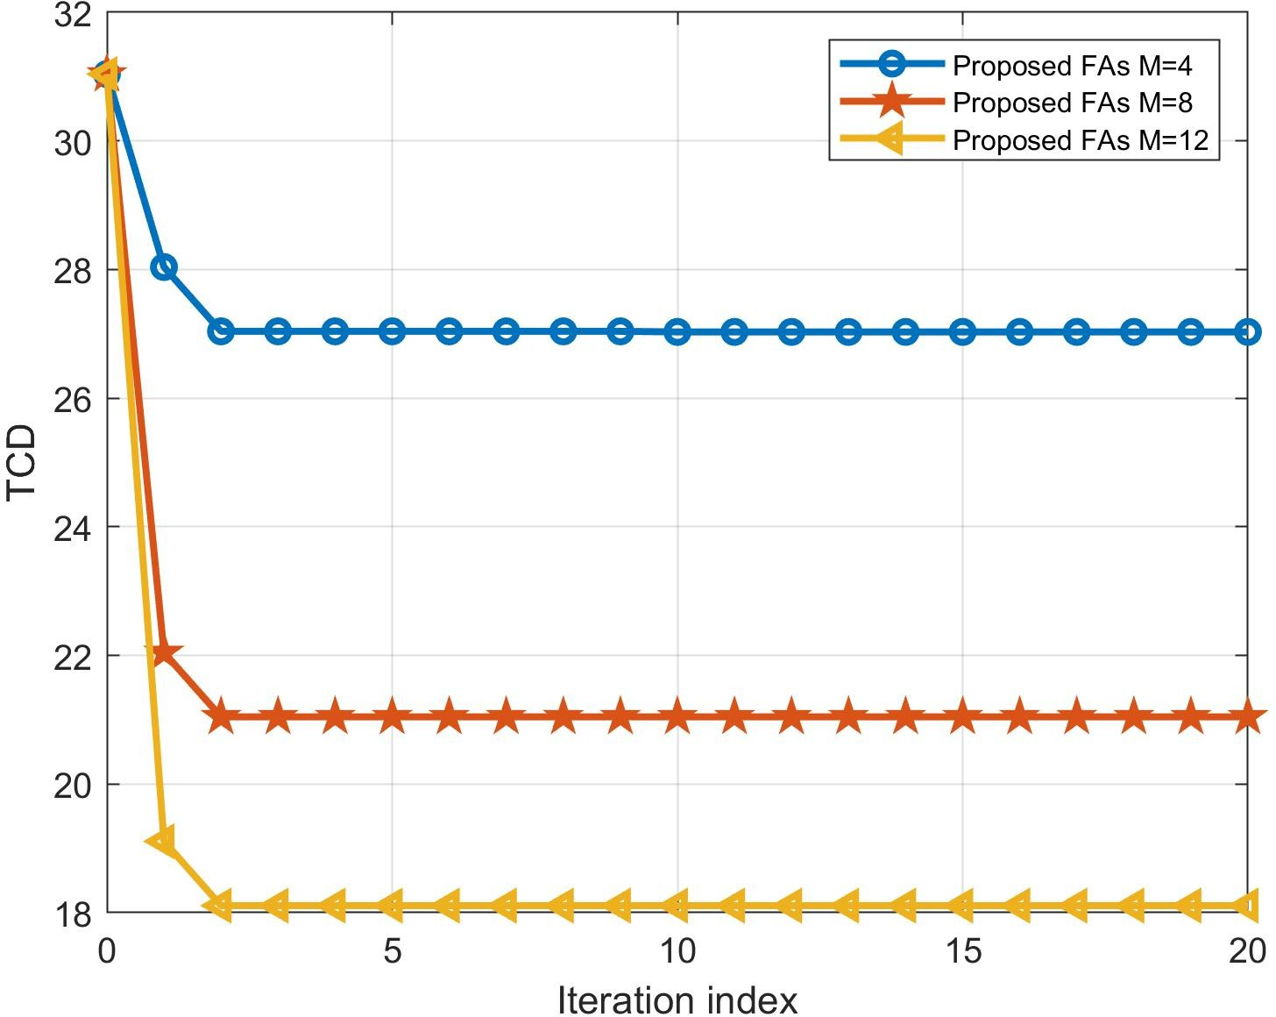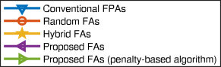

Fig. 3. Convergence of the proposed algorithm for different numbers of ports,
M = [4, 8, 12].
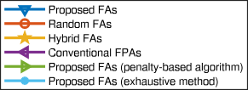

Fig. 4. TCD performance versus the number of FA ports M.

the delay benefits from additional ports become marginal. This is because, with a fixed size of the FA, the TCD first decreases markedly as the number of ports M increases and then saturates. This phenomenon occurs because reducing the port spacing leads to stronger interport correlation. Increasing M initially introduces additional diversity that improves the uplink transmission rate and thereby reduces the total time delays. Therefore, as M grows, the enhanced correlation gradually diminishes the performance gain in computation time delay. Compared to the exhaustive search method, the BCD algorithm achieves near-optimal performance in the FA system, with an average degradation rate of only 7.14%. For small K, the penalty-based algorithm delivers nearly identical TCD to our proposed scheme. For a limited number of FA ports, the difference between conventional FPAs and FA-based schemes remains negligible. As the number of FA ports increases, FA-based schemes demonstrate a significant enhancement in the TCD performance compared to FPAs under equivalent conditions. In addition, both the Hybrid FAs and random FA schemes exhibit inferior TCD performance compared to the proposed BCD algorithm. The performance
Fig. 5. TCD performance versus the edge computing resource f_{total} with different algorithms under M = 10.
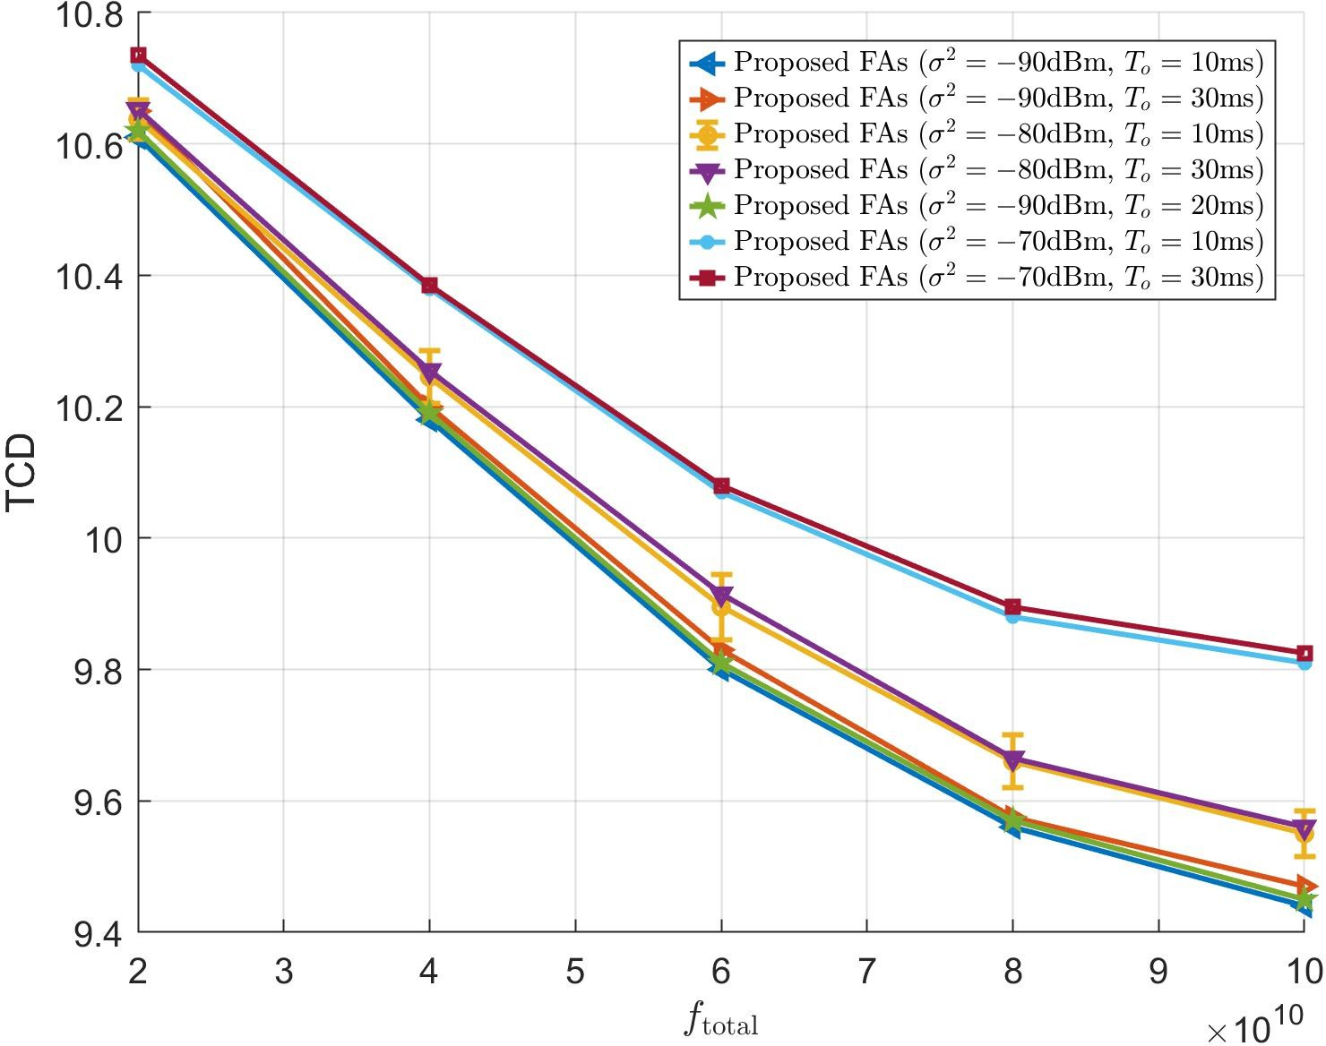

Fig. 6. TCD versus f_{total} under different noise power σ² and satellite–to-UAV propagation delay T_{o}.

gap between the FAs scheme and the Hybrid FAs and random FAs schemes further expands as M increases. This is due to the optimized placement of each antenna in the FAs scheme, which enhances beamforming gains and thereby facilitates more efficient task offloading.
The relationship between the TCD and the edge computing capacity f_{total} under various algorithms is demonstrated in Fig. 5 with M = 10. This further validates the advantages of utilizing FAs, particularly when the edge computing capacity is sufficient. Evidently, TCD decreases as edge computing resources increase and eventually stabilizes. When f_{total} is relatively small, local computation delay is the dominant factor. In contrast, with a sufficiently large edge computing capacity, the transmission delay for task offloading by GUs and SU becomes the primary contributing factor.
Fig. 6 depicts the TCD versus the edge computing resource f_{total} for different noise power levels σ² and satellite–to-UAV propagation delays T_{o}. The TCD decreases monotonically with increasing f_{total} and gradually saturates. For a fixed noise power, a larger T_{o} consistently leads to a higher TCD with almost identical curve shapes. For a fixed T_{o}, the curves with

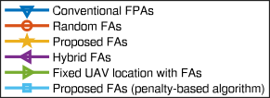
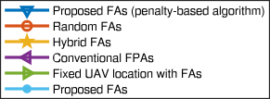
Fig. 7. TCD performance versus the computational task size of users with different algorithms under M = 16.

σ² = −70 dBm lie above those with σ² = −80 and −90 dBm, reflecting the degradation of uplink channel quality and longer offloading delays. Moreover, the TCD gap between −70 and −80 dBm is slightly larger than that between −80 and
−90 dBm. Furthermore, error bars are plotted on the curve with σ² = −80 dBm and T_{o} = 10 ms to capture the variation
of TCD at 500 random GU locations. Their magnitudes are
clearly smaller than the separations between different parame-ter curves, indicating that the proposed FA-assisted scheme is reasonably robust to the spatial randomness of user locations, while the sensitivity to such randomness becomes relatively higher when computation and communication delays are of comparable importance.
Next, Fig. 7 shows the relationship between TCD and the task size of edge computing users with M = 16. For simplicity, the task sizes of GUs and SUs are assumed to be identical and are collectively denoted as D_{k}. The TCD of all schemes increases with D_{k}, as a larger task size leads to a longer completion time, regardless of whether it is processed locally or offloaded. As D_{k} increases, the performance gap between the proposed FA scheme and other schemes gradu-ally widens. This indicates that when the task size is large, the proposed FAs scheme can more effectively reduce task offloading latency, further demonstrating the advantages of optimized antenna placement in edge computing. Moreover, relative to the baseline with fixed UAV location and FAs, the proposed scheme exhibits consistently lower TCD and a smaller growth rate with respect to D_{k}, underscoring the necessity of jointly optimizing the UAV position together with the other design variables. In addition, compared with the penalty-based algorithm for solving the receive beamforming, our proposed method maintains a slight yet consistent advan-tage across the entire range of D_{k}.
To evaluate the impact of the number of edge computing users on the TCD performance, we provide comparison results as indicated in Fig. 8. It is observed that the TCD performance of all schemes increases as the number of users K increases. The proposed FA scheme outperforms the conventional FPA scheme, further demonstrating the superiority of FA over FPA
Fig. 8. TCD performance versus the number of edge computing users K.
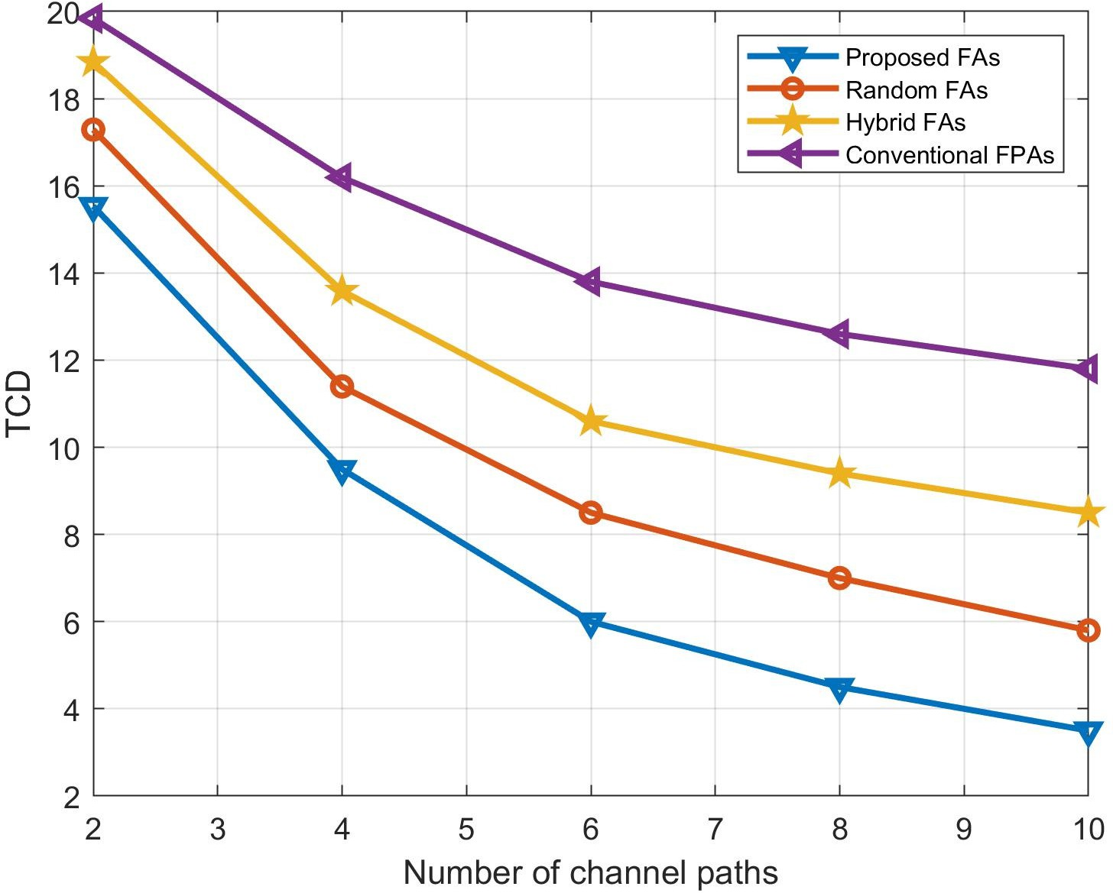

Fig. 9. TCD performance versus the number of channel paths L.

in the MEC-SAGIN system. Specifically, the schemes with FAs, hybrid FAs, and random FAs positioning achieve approx-imately 11.9%, 9.32%, and 4.7% TCD gains, respectively, compared to the FPA scheme. In addition, fixing the UAV location leads to larger TCD, with an increasing gap relative to the proposed FAs as K grows. Compared to the conventional FPA scheme, the FAs scheme can dynamically adjust antenna positions and optimize task offloading strategies, thereby mit-igating the challenges posed by limited computational and communication resources in multiuser environments. As the number of users K increases, the performance advantage of the FAs scheme becomes more pronounced, further validating its superiority in high-user-density scenarios.
Fig. 9 illustrates the relationship between the TCD and the number of channel paths of GUs and SU, that is, L. For simplicity, we set L_{r} = L_{t} = L. The TCD of all schemes decreases as L increases since a higher number of channel paths enables greater multipath diversity and facilitates more efficient offloading strategies, thereby reducing TCD. More-over, the performance gap between the proposed FA scheme and the other two schemes increases with L, further validating the effectiveness of our proposed algorithm.

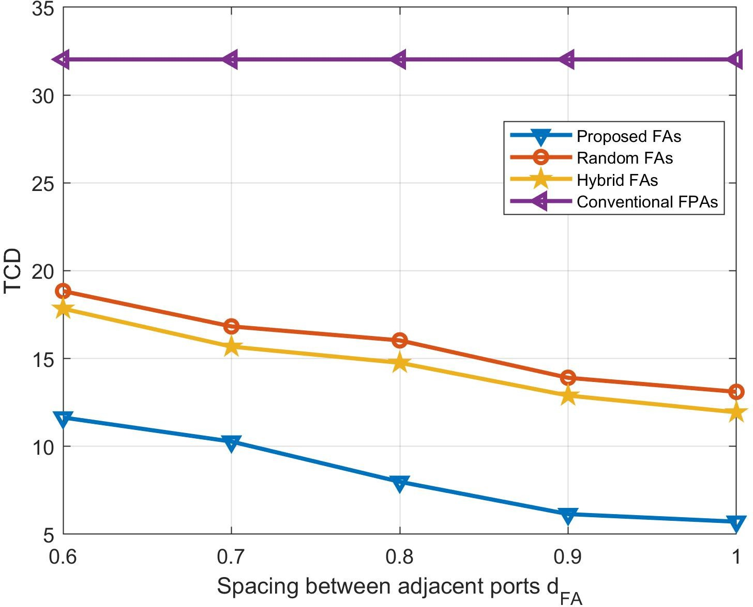

Fig. 10. TCD performance versus the spacing d_{FA}.

Finally, we compare the TCD performance of four different schemes under varying port spacing in Fig. 10. It is observed that, except for the conventional FPA scheme, the TCD of all FA-based schemes decreases as the adjacent port spacing d_{FA} increases. This indicates that enlarging the port spacing mitigates interantenna interference, thereby enhancing chan-nel quality and improving task offloading efficiency. As d_{FA} increases, the TCD of the random FAs, the proposed FAs design, and the Hybrid FAs schemes initially decrease and then converge to a constant value. This phenomenon suggests that the optimization of antenna spacing has an upper limit, and only within a certain range can it achieve the best system performance.
- Conclusion
In this article, we investigated task offloading and wireless resource management in an FA-assisted MEC-SAGIN system. To minimize the maximum TCD among edge computing users, we jointly optimized the offloading ratio, CPU frequency, FA port selection, UAV location, and receive beamforming. Simulation results demonstrated that the proposed FA design achieved significantly lower TCD than conventional FPAs and random-port schemes. These findings indicate that integrat-ing FA into MEC-SAGIN can substantially enhance channel conditions and improve overall offloading and computation efficiency.
As our future work, an energy-minimization-based design will be conceived for FA-assisted MEC-SAGIN systems that explicitly accounts for practical FA hardware con-straints and scalable multi-UAV architectures. We will also investigate reliability-oriented, secure, and privacy-preserving offloading mechanisms tailored to FA-assisted MEC-SAGIN deployments.
Acknowledgment
Any opinions, findings and conclusions or recommendations expressed in this material are those of the author(s) and do not reflect the views of the National Research Foundation, Singapore.
References

- T. Mai, H. Yao, N. Zhang, L. Xu, M. Guizani, and S. Guo, “Cloud mining pool aided blockchain-enabled Internet of Things: An evolu-tionary game approach,” IEEE Trans. Cloud Comput., vol. 11, no. 1,
pp. 692–703, Jan. 2023.
- Y. Zhu, H. Yao, T. Mai, W. He, N. Zhang, and M. Guizani, “Multiagent reinforcement-learning-aided service function chain deploy-ment for Internet of Things,” IEEE Internet Things J., vol. 9, no. 17,
pp. 15674–15684, Sep. 2022.
- W. Shi, J. Cao, Q. Zhang, Y. Li, and L. Xu, “Edge computing: Vision and challenges,” IEEE Internet Things J., vol. 3, no. 5, pp. 637–646, Oct. 2016.
- C. Qiu, H. Yao, C. Jiang, S. Guo, and F. Xu, “Cloud computing assisted blockchain-enabled Internet of Things,” IEEE Trans. Cloud Comput., vol. 10, no. 1, pp. 247–257, Jan. 2022.
- P. Mach and Z. Becvar, “Mobile edge computing: A survey on architec-ture and computation offloading,” IEEE Commun. Surveys Tuts., vol. 19, no. 3, pp. 1628–1656, 3rd Quart., 2017.
- X. Chen, L. Jiao, W. Li, and X. Fu, “Efficient multi-user computation offloading for mobile-edge cloud computing,” IEEE/ACM Trans. Netw., vol. 24, no. 5, pp. 2795–2808, Oct. 2016.
- Y. Mao, J. Zhang, and K. B. Letaief, “Dynamic computation offloading for mobile-edge computing with energy harvesting devices,” IEEE J. Sel. Areas Commun., vol. 34, no. 12, pp. 3590–3605, Dec. 2016.
- T. Taleb, K. Samdanis, B. Mada, H. Flinck, S. Dutta, and D. Sabella, “On multi-access edge computing: A survey of the emerging 5G network edge cloud architecture and orchestration,” IEEE Commun. Surveys Tuts., vol. 19, no. 3, pp. 1657–1681, 3rd Quart., 2017.
- S. Wang, X. Zhang, Y. Zhang, L. Wang, J. Yang, and W. Wang, “A survey on mobile edge networks: Convergence of computing, caching and communications,” IEEE Access, vol. 5, pp. 6757–6779, 2017.
- T. X. Tran, A. Hajisami, P. Pandey, and D. Pompili, “Collaborative mobile edge computing in 5G networks: New paradigms, scenarios, and challenges,” IEEE Commun. Mag., vol. 55, no. 4, pp. 54–61, Apr. 2017.
- J. Liu, Y. Shi, Z. M. Fadlullah, and N. Kato, “Space-air-ground integrated network: A survey,” IEEE Commun. Surveys Tuts., vol. 20, no. 4,
pp. 2714–2741, 4th Quart., 2018.
- C. Zhou et al., “Deep reinforcement learning for delay-oriented IoT task scheduling in SAGIN,” IEEE Trans. Wireless Commun., vol. 20, no. 2,
pp. 911–925, Feb. 2021.
- N. Cheng et al., “Space/aerial-assisted computing offloading for IoT applications: A learning-based approach,” IEEE J. Sel. Areas Commun., vol. 37, no. 5, pp. 1117–1129, May 2019.
- N. Kato et al., “Optimizing space-air-ground integrated networks by artificial intelligence,” IEEE Wireless Commun., vol. 26, no. 4,
pp. 140–147, Aug. 2019.
- B. Cao et al., “Edge–cloud resource scheduling in space–air–ground-integrated networks for Internet of Vehicles,” IEEE Internet Things J., vol. 9, no. 8, pp. 5765–5772, Apr. 2022.
- M. Jia, J. Wu, Q. Guo, and Y. Yang, “Service-oriented SAGIN with per-vasive intelligence for resource-constrained users,” IEEE Netw., vol. 38, no. 2, pp. 79–86, Mar. 2024.
- B. Chen, N. Li, Y. Li, X. Tao, and G. Sun, “Energy efficient hybrid offloading in space-air-ground integrated networks,” in Proc. IEEE Wireless Commun. Netw. Conf. (WCNC), Apr. 2022, pp. 1319–1324.
- S. Yoo, S. Jeong, J. Kim, and J. Kang, “Cache-assisted mobile-edge computing over space–air–ground integrated networks for extended reality applications,” IEEE Internet Things J., vol. 11, no. 10,
pp. 18306–18319, May 2024.
- J. Du et al., “Joint optimization in blockchain- and MEC-enabled space–air–ground integrated networks,” IEEE Internet Things J., vol. 11, no. 19, pp. 31862–31877, Oct. 2024.
- Y. Pang, D. Wang, D. Wang, L. Guan, C. Zhang, and M. Zhang, “A space-air-ground integrated network assisted maritime communication network based on mobile edge computing,” in Proc. IEEE World Congr. Services (SERVICES), Oct. 2020, pp. 269–274.
- Z. Hu et al., “Joint resources allocation and 3D trajectory opti-mization for UAV-enabled space-air-ground integrated networks,” IEEE Trans. Veh. Technol., vol. 72, no. 11, pp. 14214–14229, Nov. 2023.
- Y. Zhang, J. Wang, Q. Li, J. Chen, H. Feng, and S. He, “Joint communication, sensing, and computing in space–air–ground integrated networks: System architecture and handover procedure,” IEEE Veh. Technol. Mag., vol. 19, no. 2, pp. 70–78, Jun. 2024.

- J. Li et al., “A learning-based stochastic game for energy efficient optimization of UAV trajectory and task offloading in space/aerial edge computing,” IEEE Trans. Veh. Technol., vol. 74, no. 6, pp. 1–16, Jun. 2025.
- W. Zhu, X. Deng, J. Gui, H. Zhang, and G. Min, “Cost-effective task offloading and resource scheduling for mobile edge computing in 6G space-air–ground integrated network,” IEEE Internet Things J., vol. 12, no. 12, pp. 19428–19442, Jun. 2025.
- K.-K. Wong, K.-F. Tong, Y. Zhang, and Z. Zhongbin, “Fluid antenna system for 6G: When Bruce lee inspires wireless communications,” Electron. Lett., vol. 56, no. 24, pp. 1288–1290, Nov. 2020.
- K.-K. Wong, W. K. New, X. Hao, K.-F. Tong, and C.-B. Chae, “Fluid antenna system—Part I: Preliminaries,” IEEE Commun. Lett., vol. 27, no. 8, pp. 1919–1923, Aug. 2023.
- K.-K. Wong, A. Shojaeifard, K.-F. Tong, and Y. Zhang, “Fluid antenna systems,” IEEE Trans. Wireless Commun., vol. 20, no. 3,
pp. 1950–1962, Mar. 2021.
- W. K. New et al., “A tutorial on fluid antenna system for 6G networks: Encompassing communication theory, optimization methods and hardware designs,” IEEE Commun. Surveys Tuts., vol. 27, no. 4,
pp. 2325–2377, 4th Quart., 2025.
- K.-K. Wong and K.-F. Tong, “Fluid antenna multiple access,” IEEE Trans. Wireless Commun., vol. 21, no. 7, pp. 4801–4815, Jul. 2022.
- H. Xu et al., “Channel estimation for FAS-assisted multiuser mmWave systems,” IEEE Commun. Lett., vol. 28, no. 3, pp. 632–636, Mar. 2024.
- H. Xu et al., “Capacity maximization for FAS-assisted multiple access channels,” IEEE Trans. Commun., vol. 73, no. 7, pp. 4713–4731, Jul. 2025.
- W. Ma, L. Zhu, and R. Zhang, “Multi-beam forming with movable-antenna array,” IEEE Commun. Lett., vol. 28, no. 3, pp. 697–701, Mar. 2024.
- L. Zhu, W. Ma, and R. Zhang, “Movable-antenna array enhanced beamforming: Achieving full array gain with null steering,” IEEE Commun. Lett., vol. 27, no. 12, pp. 3340–3344, Dec. 2023.
- K.-K. Wong, K.-F. Tong, Y. Chen, and Y. Zhang, “Fast fluid antenna multiple access enabling massive connectivity,” IEEE Commun. Lett., vol. 27, no. 2, pp. 711–715, Feb. 2023.
- W. Mei, X. Wei, B. Ning, Z. Chen, and R. Zhang, “Movable-antenna position optimization: A graph-based approach,” IEEE Wireless Com-mun. Lett., vol. 13, no. 7, pp. 1853–1857, Jul. 2024.
- P. Chen, Y. Yang, B. Lyu, Z. Yang, and A. Jamalipour, “Movable-antenna-enhanced wireless-powered mobile-edge computing systems,” IEEE Internet Things J., vol. 11, no. 21, pp. 35505–35518, Nov. 2024.
- Y. Zuo, J. Guo, B. Sheng, C. Dai, F. Xiao, and S. Jin, “Fluid antenna for mobile edge computing,” IEEE Commun. Lett., vol. 28, no. 7,
pp. 1728–1732, Jul. 2024.
- L. Zhu, X. Pi, W. Ma, Z. Xiao, and R. Zhang, “Dynamic beam coverage for satellite communications aided by movable-antenna array,” IEEE Trans. Wireless Commun., vol. 24, no. 3, pp. 1916–1933, Mar. 2025.
- Y. Chen, M. Chen, H. Xu, Z. Yang, K.-K. Wong, and Z. Zhang, “Joint beamforming and antenna design for near-field fluid antenna system,” IEEE Wireless Commun. Lett., vol. 14, no. 2, pp. 415–419, Feb. 2025.
- L. Zhu, W. Ma, B. Ning, and R. Zhang, “Movable-antenna enhanced multiuser communication via antenna position optimization,” IEEE Trans. Wireless Commun., vol. 23, no. 7, pp. 7214–7229, Jul. 2023.
- S. Boyd and L. Vandenberghe, Convex Optimization. Cambridge, U.K.: Cambridge Univ. Press, 2004.


Jingwen Zhao (Graduate Student Member, IEEE) received the B.S. degree in electronic information engineering from Zhengzhou University, Zhengzhou, China, in 2019. She is currently pursuing the Ph.D. degree in information and communications engi-neering with the National Mobile Communications Research Laboratory, Southeast University, Nanjing, China.
She was a Visiting Student with Singapore Uni-versity of Technology and Design, Singapore, from 2023 to 2024. Her research interests mainly include
mobile edge computing, fluid antenna, intelligent reflection surface, secure communication, and resource allocation in wireless communications.
Ming Chen received the Ph.D. degree from the Department of Mathematics, Nanjing University, Nanjing, China, in 1996.
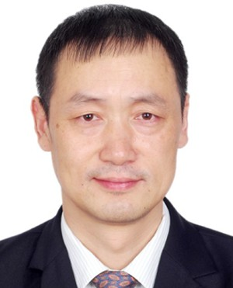
In July 1996, he was a Lecturer at the National Mobile Communications Research Labo-ratory, Southeast University, Nanjing. From 1998 to 2003, he was an Associate Professor, and since 2003, he has been a Professor at the Laboratory. He has completed more than 50 research projects in the role of the director by now, among which there are more than 15 projects issued by national
ministries, supervised more than 30 Ph.D. and 150 M.Sc. students and published more than 350 journal articles as a co-author. His research interests include baseband signal processing, radio and computing resource allocation and network planning for all generation mobile communication systems, visible light communication systems, mobile edge computing systems, and satellite mobile communications.
Dr. Chen won twice the first-level provincial progress awards in science and technology.

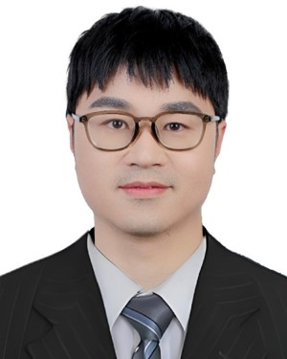
Zhaohui Yang (Member, IEEE) received the bachelor’s and Ph.D. degrees from Southeast Univer-sity, Nanjing, China, in 2014 and 2018, respectively. He is currently a ZJU Young Professor with Zhejiang Key Laboratory of Information Process-ing Communication and Networking, College of Information Science and Electronic Engineering, Zhejiang University, Hangzhou, China. From 2018 to 2020, he was a Post-Doctoral Research Associate at the Center for Telecommunications Research, Department of Informatics, King’s College London,
London, U.K. From 2020 to 2022, he was a Research Fellow at the Depart-ment of Electronic and Electrical Engineering, University College London, London. His research interests include joint communication, sensing, and computation, federated learning, and semantic communication.
Dr. Yang received the IEEE Communications Society Asia-Pacific Out-standing Young Researcher Award, the IEEE Marconi Prize Paper Award, and the IEEE Katherine Johnson Young Author Paper Award. He cur-rently serves as an Associate Editor for IEEE TRANSACTIONS ON GREEN COMMUNICATIONS AND NETWORKING (TGCN), IEEE COMMUNICATIONS LETTERS (CL), and IEEE TRANSACTIONS ON MACHINE LEARNING IN
COMMUNICATIONS AND NETWORKING (TMLCN). He has served as a Guest Editor for several journals, including IEEE JOURNAL ON SELECTED AREAS IN COMMUNICATIONS.

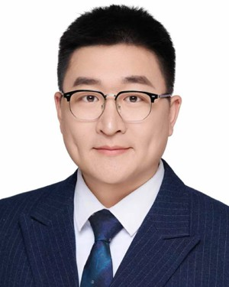
Hao Xu (Senior Member, IEEE) received the B.S. degree in communication engineering from Nanjing University of Science and Technology, Nanjing, China, in 2013, and the Ph.D. degree in infor-mation and communication engineering from the National Mobile Communications Research Labo-ratory, Southeast University, Nanjing, in 2019.
From 2019 to 2021, he worked as an Alexander von Humboldt (AvH) Post-Doctoral Research Fel-low at the Faculty of Electrical Engineering and Computer Science, Technical University of Berlin,
Berlin, Germany. From 2021 to 2025, he worked as a Marie Skłodowska-Curie Actions (MSCA) Individual Fellow at the Department of Electronic and Elec-trical Engineering, University College London, London, U.K. He is currently a Professor with the National Mobile Communications Research Laboratory, Southeast University. His research interests mainly include communication theory, information theory, mathematical optimization, MIMO systems, and privacy and security.
Dr. Xu was a recipient of the 2024 IEEE ISTT Best Paper Award. He has been serving as an Associate Editor for IEEE TRANSACTIONS ON COMMUNICATIONS since August 2024 and IET Communications since August 2021.

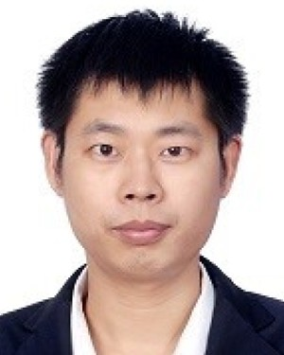
Cunhua Pan (Senior Member, IEEE) is a Full Professor with Southeast University, Nanjing, China. He has published over 200 IEEE journal articles. His papers got over 23 000 Google Scholar citations with an H-index of 76. He is a Clarivate Highly Cited researcher. His research interests mainly include reconfigurable intelligent surfaces (RISs), AI for wireless, near field communications and sensing, and integrated sensing and communications.
Dr. Pan received the IEEE ComSoc Leonard G. Abraham Prize in 2022, the IEEE ComSoc Asia-
Pacific Outstanding Young Researcher Award in 2022, the IEEE ComSoc Fred W. Ellersick Prize in 2024, the IEEE ComSoc CTTC Early Achievement Award in 2024, the IEEE ComSoc SPCC Early Achievement Award in 2024, the IEEE ComSoc RCC Early Achievement Award in 2025, the IEEE ComSoc Heinrich Hertz Award in 2025, and the IEEE ComSoc SPCC Best Paper Award in 2025. His supervised Ph.D. thesis won the IEEE Signal Processing Society Best Phd Dissertation Award in 2024. He is/was an Editor of IEEE TRANSACTIONS ON COMMUNICATIONS, IEEE TRANSACTIONS ON VEHICULAR TECHNOLOGY, IEEE WIRELESS COMMUNICATION LETTERS,
and IEEE COMMUNICATIONS LETTERS. He serves as the Leading Guest Editor for IEEE JOURNAL ON SELECTED AREAS IN COMMUNICATIONS and IEEE JOURNAL OF SELECTED TOPICS IN SIGNAL PROCESSING.
Kai-Kit Wong (Fellow, IEEE) received the B.Eng., M.Phil., and the Ph.D. degrees in electrical and electronic engineering from Hong Kong University of Science and Technology, Hong Kong, in 1996, 1998, and 2001, respectively.
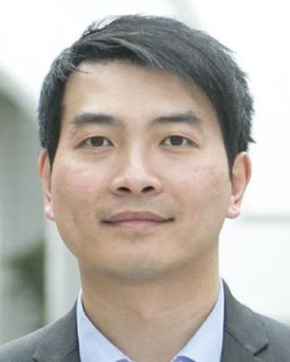
After graduation, he took up academic and research positions at the University of Hong Kong, Hong Kong; Lucent Technologies, Murray Hill, NJ, USA; Bell-Labs, Holmdel; the Smart Antennas Research Group of Stanford University, CA, USA; and the University of Hull, U.K. He is the Chair
in Wireless Communications at the Department of Electronic and Electrical Engineering, University College London, U.K. His current research centers around 6G and beyond mobile communications.
Dr. Wong is a Fellow of CIC and IET. He served as the Editor-in-Chief for IEEE WIRELESS COMMUNICATIONS LETTERS between 2020 and 2023.

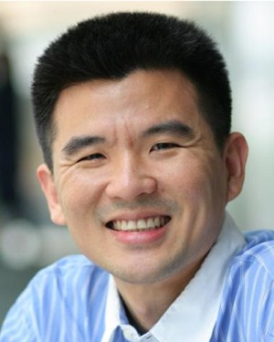
Tony Q. S. Quek (Fellow, IEEE) received the B.E. and M.E. degrees in electrical and electronics engi-neering from Tokyo Institute of Technology, Tokyo, Japan, in 1998 and 2000, respectively, and the Ph.D. degree in electrical engineering and computer sci-ence from Massachusetts Institute of Technology, Cambridge, MA, USA, in 2008.
Currently, he is the Associate Provost (AI & Digital Innovation) and the Cheng Tsang Man Chair Professor with Singapore University of Technology and Design (SUTD), Singapore. He also serves as
the Director of the Future Communications Research and Development Program and the ST Engineering Distinguished Professor. He is a co-founder of Silence Laboratories and NeuroRAN. His current research topics include wireless communications and networking, network intelligence, nonterrestrial networks, open radio access network, AI-RAN, and 6G.
Dr. Quek is a WWRF Fellow, an AIIA Fellow, and a fellow of the Academy of Engineering Singapore. He was honored with the 2008 Philip Yeo Prize for Outstanding Achievement in Research, the 2012 IEEE William R. Bennett Prize, the 2015 SUTD Outstanding Education Awards–Excellence in Research, the 2016 IEEE Signal Processing Society Young Author Best Paper Award, the 2017 CTTC Early Achievement Award, the 2017 IEEE ComSoc AP Outstanding Paper Award, the 2020 IEEE Communications Society Young Author Best Paper Award, the 2020 IEEE Stephen O. Rice Prize, the 2020 Nokia Visiting Professor, the 2022 IEEE Signal Processing Society Best Paper Award, the 2024 IIT Bombay International Award For Excellence in Research in Engineering and Technology, the IEEE Communications Society WTC Recognition Award 2024, and the Public Administration Medal (Bronze).

